Table of Contents

UNITED STATES
SECURITIES AND EXCHANGE COMMISSION
Washington, D.C. 20549
FORM 10-Q
(Mark One)
☒ |  |  | QUARTERLY REPORT PURSUANT TO SECTION 13 OR 15(d) OF THE SECURITIES EXCHANGE ACT OF 1934
For the quarter ended September 30, 2023
OR
☐ |  |  | TRANSITION REPORT PURSUANT TO SECTION 13 OR 15(d) OF THE SECURITIES EXCHANGE ACT OF 1934
For the transition period from to

Commission file number 001-40049

SPRINGBIG HOLDINGS, INC.
(Exact name of registrant as specified in its charter)
Delaware |  |  |  |  |  | 88-2789488
(State or other jurisdiction of incorporation) |  |  |  |  |  | (I.R.S Employer Identification No.)

621 NW 53rd Street
Ste. 260
Boca Raton, |  |  | Florida |  |  |  |  |  | 33487
(Address of principal executive offices) |  |  |  |  |  |  |  |  | (zip code)

Registrant’s telephone number, including area code (800) 772-9172

Securities registered pursuant to Section 12(b) of the Act:
Title of each class |  |  |  |  |  | Trading Symbol(s) |  |  |  |  |  | Name of each exchange on which registered
None

Indicate by check mark whether the registrant: (1) has filed all reports required to be filed by Section 13 or 15(d) of the Securities Exchange Act of 1934 during the preceding 12 months (or for such shorter period that the registrant was required to file such reports); and (2) has been subject to such filing requirements for the past 90 days. Yes No
Indicate by check mark whether the registrant has submitted electronically and posted on its corporate web site, if any, every Interactive Data File required to be submitted and posted pursuant to Rule 405 of Regulation S-T (§232.405 of this chapter) during the preceding 12 months (or for such shorter period that the registrant was required to submit and post such files). Yes No

Table of Contents
Indicate by check mark whether the registrant is a large accelerated filer, an accelerated filer, a non-accelerated filer, or a smaller reporting company. See the definitions of “large accelerated filer,” “accelerated filer” and “smaller reporting company” in Rule 12b-2 of the Exchange Act. (Check one):
Large accelerated filer |  |  |  |  |  | Accelerated filer
Non-accelerated filer |  |  | ☒ |  |  | Smaller reporting company |  |  | ☒
 |  |  |  |  |  | Emerging growth company |  |  | ☒

If an emerging growth company, indicate by check mark if the registrant has elected not to use the extended transition period for complying with any new or revised financial accounting standards provided pursuant to Section 13(a) of the Exchange Act.
Indicate by check mark whether the registrant is a shell company (as defined in Rule 12b-2 of the Act). Yes No
As of November 12, 2023, there were 44,053,502 shares of common stock, $0.0001 par value issued and outstanding.

SPRINGBIG, INC
TABLE OF CONTENTS

 |  |  |  |  |  |  |  |  | Page
 |  |  | Part I – Financial Information
Item 1. |  |  | Financial Statements (Unaudited) |  |  |  |  |  | 1
 |  |  | Consolidated Balance Sheets as of September 30, 2023 and December 31, 2022 |  |  |  |  |  | 1
 |  |  | Consolidated Statements of Operations for the three and nine months ended September 30, 2023 and 2022 |  |  |  |  |  | 2
 |  |  | Consolidated Statements of Changes in Stockholder’s Equity (Deficit) for the three and nine months ended September 30, 2023 and 2022 |  |  |  |  |  | 3
 |  |  | Consolidated Statements of Cash Flows for the nine months ended September 30, 2023 and 2022 |  |  |  |  |  | 5
 |  |  | Notes to the Consolidated Financial Statements |  |  |  |  |  | 6
Item 2. |  |  | Management’s Discussion and Analysis of Financial Condition and Results of Operations |  |  |  |  |  | 25
Item 3. |  |  | Quantitative and Qualitative Disclosure About Market Risk |  |  |  |  |  | 37
Item 4. |  |  | Controls and Procedures |  |  |  |  |  | 37
 |  |  | Part II – Other Information
Item 1. |  |  | Legal Proceedings |  |  |  |  |  | 37
Item 1A. |  |  | Risk Factors |  |  |  |  |  | 38
Item 2. |  |  | Unregistered Sales of Equity Securities and Use of Proceeds |  |  |  |  |  | 39
Item 3. |  |  | Defaults Upon Senior Securities |  |  |  |  |  | 39
Item 4. |  |  | Mine Safety Disclosures |  |  |  |  |  | 39
Item 5. |  |  | Other Information |  |  |  |  |  | 39
Item 6. |  |  | Exhibits |  |  |  |  |  | 40
 |  |  | Signatures |  |  |  |  |  | 41

"SpringBig," "the Company," "we," "us" or "our" refer to SpringBig Holdings, Inc. and its subsidiaries, unless the context otherwise requires.

Forward Looking Statements

This Quarterly Report on Form 10-Q contains forward looking statements that are subject to risks and uncertainties. All statements other than statements of historical fact included in this Quarterly Report on Form 10-Q are forward looking statements. Forward looking statements include our current expectations and projections relating to our financial condition, results of operations, plans, objectives, future performance and business. You can identify forward looking statements by the fact that they do not relate strictly to historical or current facts. These statements may include words such as "anticipate," "estimate," "expect," "project," "plan," "intend," "believe," "may," "will," "should," "can have," "likely" and other words and terms of similar meaning in connection with any discussion of the timing or nature of future cash flows, operating or financial performance or other events. These forward looking statements are not historical facts, and are based on current expectations, estimates and projections about our industry and Company, management’s beliefs and certain assumptions made by management, many of which, by their nature, are inherently uncertain and beyond our control. Accordingly, readers are cautioned that any such forward looking statements are not guarantees of future performance and are subject to certain risks, uncertainties and assumptions that are difficult to predict. Although we believe that the expectations reflected in such forward looking statements are reasonable as of the date made, results may prove to be materially different. Unless otherwise required by law, we disclaim any obligation to update our view of any such risks or uncertainties or to announce publicly the result of any revisions to the forward-looking statements made in this report.

Factors that could cause our actual results and our financial condition to differ materially from those indicated in our forward looking statements include, but are not limited to, the following:

•trends in the cannabis industry and SpringBig’s market size, including with respect to the potential total addressable market in the industry;
•SpringBig’s growth prospects;
•new product and service offerings SpringBig may introduce in the future;
•the price of SpringBig’s securities, including volatility resulting from changes in the competitive and highly regulated industry in which SpringBig operates and plans to operate, variations in performance across competitors, changes in laws and regulations affecting SpringBig’s business and changes in the combined capital structure;
•the ability to implement business plans, forecasts, and other expectations, and identify and realize additional opportunities; and
•other risks and uncertainties indicated from time to time in filings made with the Securities and Exchange Commission (the “SEC”).

These risks are not exhaustive. New risk factors emerge from time to time and it is not possible for our management to predict all risk factors, nor can we assess the impact of all factors on our business or the extent to which any factor, or combination of factors, may cause actual results to differ materially from those contained in any forward-looking statements. Should one or more of these risks or uncertainties materialize or should any of the assumptions made by the management of SpringBig prove incorrect, actual results may vary in material respects from those projected in these forward-looking statements. Additional information concerning these and other factors that may impact the operations and projections discussed herein can be found in the section entitled “Risk Factors” and in our periodic filings with the SEC. Our SEC filings are available publicly on the SEC’s website at www.sec.gov.

You should read this Quarterly Report on Form 10-Q completely and with the understanding that our actual future results, levels of activity and performance as well as other events and circumstances may be materially different from what we expect. We qualify all of our forward-looking statements by these cautionary statements.

Part I – Financial Information

Item 1. Financial Statements
SPRINGBIG HOLDINGS, INC.
CONSOLIDATED BALANCE SHEETS

 |  |  | September 30, 2023 |  |  |  |  |  | December 31, 2022
 |  |  | (unaudited) |  |  |  |  |  | (audited)
 |  |  | (In thousands except share data)
ASSETS
Assets
Current assets:
Cash and cash equivalents |  |  | $ | 293 |  |  |  |  | $ | 3,546
Accounts receivable, net |  |  | 3,871 |  |  |  |  |  | 2,889
Contract assets |  |  | 289 |  |  |  |  |  | 333
Prepaid expenses and other current assets |  |  | 1,213 |  |  |  |  |  | 1,505
Total current assets |  |  | 5,666 |  |  |  |  |  | 8,273
Operating lease asset |  |  | 522 |  |  |  |  |  | 750
Property and equipment, net |  |  | 425 |  |  |  |  |  | 375
Convertible note receivable |  |  | 269 |  |  |  |  |  | 259
Total assets |  |  | $ | 6,882 |  |  |  |  | $ | 9,657
LIABILITIES AND STOCKHOLDERS’ EQUITY
Liabilities
Current liabilities:
Accounts payable |  |  | $ | 2,622 |  |  |  |  | $ | 1,056
Accrued expenses and other current liabilities |  |  | 2,376 |  |  |  |  |  | 2,554
Short-term cash advance |  |  | 780 |  |  |  |  |  | —
Current maturities of long-term debt |  |  | 4,560 |  |  |  |  |  | 5,451
Deferred payroll tax credits |  |  | 1,751 |  |  |  |  |  | —
Deferred revenue |  |  | 35 |  |  |  |  |  | 291
Operating lease liability - current |  |  | 390 |  |  |  |  |  | 465
Total current liabilities |  |  | 12,514 |  |  |  |  |  | 9,817
Notes payable |  |  | — |  |  |  |  |  | 2,814
Operating lease liability - non-current |  |  | 153 |  |  |  |  |  | 316
Warrant liabilities |  |  | 80 |  |  |  |  |  | 338
Total liabilities |  |  | $ | 12,747 |  |  |  |  | $ | 13,285
Commitments and Contingencies
Stockholders’ Deficit
Common stock par value $0.0001 per share, 300,000,000 authorized at September 30, 2023; 43,478,502 issued and outstanding as of September 30, 2023; (par value $0.0001 per share, 300,000,000 authorized at December 31, 2022; 26,659,711 issued and outstanding as of December 31, 2022) |  |  | 4 |  |  |  |  |  | 3
Additional paid-in-capital |  |  | 27,495 |  |  |  |  |  | 22,701
Accumulated deficit |  |  | (33,364) |  |  |  |  |  | (26,332)
Total stockholders’ deficit |  |  | $ | (5,865) |  |  |  |  | $ | (3,628)
Total liabilities and stockholders’ deficit |  |  | $ | 6,882 |  |  |  |  | $ | 9,657

1
The accompanying notes are an integral part of these financial statements

SPRINGBIG HOLDINGS, INC.
CONSOLIDATED STATEMENTS OF OPERATIONS (UNAUDITED)

 |  |  |  |  |  | Three Months Ended September 30, |  |  |  |  |  |  |  |  |  |  |  | Nine Months Ended September 30,
 |  |  |  |  |  | 2023 |  |  |  |  |  | 2022 |  |  |  |  |  | 2023 |  |  |  |  |  | 2022
 |  |  |  |  |  |  |  |  |  |  |  | (revised) |  |  |  |  |  |  |  |  |  |  |  | (revised)
 |  |  |  |  |  | (In thousands, except share and per share data) |  |  |  |  |  |  |  |  |  |  |  | (In thousands, except share and per share data)
Revenues |  |  |  |  |  | $ | 6,888 |  |  |  |  | $ | 7,232 |  |  |  |  | $ | 21,259 |  |  |  |  | $ | 19,859
Cost of revenues |  |  |  |  |  | 1,604 |  |  |  |  |  | 1,688 |  |  |  |  |  | 4,465 |  |  |  |  |  | 5,209
Gross profit |  |  |  |  |  | 5,284 |  |  |  |  |  | 5,544 |  |  |  |  |  | 16,794 |  |  |  |  |  | 14,650
Operating expenses
Selling, servicing and marketing |  |  |  |  |  | 1,864 |  |  |  |  |  | 3,075 |  |  |  |  |  | 6,528 |  |  |  |  |  | 9,103
Technology and software development |  |  |  |  |  | 1,912 |  |  |  |  |  | 2,811 |  |  |  |  |  | 6,257 |  |  |  |  |  | 8,358
General and administrative |  |  |  |  |  | 4,200 |  |  |  |  |  | 3,215 |  |  |  |  |  | 10,202 |  |  |  |  |  | 8,790
Total operating expenses |  |  |  |  |  | 7,976 |  |  |  |  |  | 9,101 |  |  |  |  |  | 22,987 |  |  |  |  |  | 26,251
Loss from operations |  |  |  |  |  | (2,692) |  |  |  |  |  | (3,557) |  |  |  |  |  | (6,193) |  |  |  |  |  | (11,601)
Interest income |  |  |  |  |  | 3 |  |  |  |  |  | 7 |  |  |  |  |  | 17 |  |  |  |  |  | 7
Interest expense |  |  |  |  |  | (400) |  |  |  |  |  | (320) |  |  |  |  |  | (1,114) |  |  |  |  |  | (632)
Change in fair value of warrants |  |  |  |  |  | 347 |  |  |  |  |  | 811 |  |  |  |  |  | 258 |  |  |  |  |  | 3,691
Loss before income tax |  |  |  |  |  | (2,742) |  |  |  |  |  | (3,059) |  |  |  |  |  | (7,032) |  |  |  |  |  | (8,535)
Income tax expense |  |  |  |  |  | — |  |  |  |  |  | — |  |  |  |  |  | — |  |  |  |  |  | —
Net loss |  |  |  |  |  | $ | (2,742) |  |  |  |  | $ | (3,059) |  |  |  |  | $ | (7,032) |  |  |  |  | $ | (8,535)
Net loss per common share:
Basic and diluted |  |  |  |  |  | $ | (0.07) |  |  |  |  | $ | (0.12) |  |  |  |  | $ | (0.21) |  |  |  |  | $ | (0.41)
Weighted-average common shares outstanding
Basic and diluted |  |  |  |  |  | 41,897,995 |  |  |  |  |  | 25,629,910 |  |  |  |  |  | 33,452,502 |  |  |  |  |  | 20,928,363

2
The accompanying notes are an integral part of these financial statements

SPRINGBIG HOLDINGS, INC.
CONSOLIDATED STATEMENTS OF CHANGES IN STOCKHOLDER’S EQUITY (DEFICIT) (UNAUDITED)

Three Months Ended September 30, 2023

 |  |  |  |  |  | Common Stock |  |  |  |  |  |  |  |  |  |  |  | Additional Paid-in- |  |  |  |  |  | Accumulated
 |  |  |  |  |  | Shares |  |  |  |  |  | Amount |  |  |  |  |  | Capital |  |  |  |  |  | Deficit |  |  |  |  |  | Total
Balance at June 30, 2023 |  |  |  |  |  | 41,402,847 |  |  |  |  |  | $ | 4 |  |  |  |  | $ | 26,975 |  |  |  |  | $ | (30,622) |  |  |  |  | $ | (3,643)
Stock-based compensation |  |  |  |  |  | — |  |  |  |  |  | — |  |  |  |  |  | 239 |  |  |  |  |  | — |  |  |  |  |  | 239
Issue of common stock (1) |  |  |  |  |  | 150,000 |  |  |  |  |  | — |  |  |  |  |  | 18 |  |  |  |  |  | — |  |  |  |  |  | 18
Issue of common stock (2) |  |  |  |  |  | 1,700,000 |  |  |  |  |  | — |  |  |  |  |  | 263 |  |  |  |  |  | — |  |  |  |  |  | 263
RSU vesting |  |  |  |  |  | 225,655 |  |  |  |  |  | — |  |  |  |  |  | — |  |  |  |  |  | — |  |  |  |  |  | —
Net loss |  |  |  |  |  | — |  |  |  |  |  | — |  |  |  |  |  | — |  |  |  |  |  | (2,742) |  |  |  |  |  | (2,742)
Balance at September 30, 2023 |  |  |  |  |  | 43,478,502 |  |  |  |  |  | $ | 4 |  |  |  |  | $ | 27,495 |  |  |  |  | $ | (33,364) |  |  |  |  | $ | (5,865)
(1) Common shares issued in exchange for services rendered
(2) Common shares issued in connection with settlement of litigation

Nine Months Ended September 30, 2023

 |  |  |  |  |  | Common Stock |  |  |  |  |  |  |  |  |  |  |  | Additional Paid-in- |  |  |  |  |  | Accumulated
 |  |  |  |  |  | Shares |  |  |  |  |  | Amount |  |  |  |  |  | Capital |  |  |  |  |  | Deficit |  |  |  |  |  | Total
Balance at December 31, 2022 |  |  |  |  |  | 26,659,711 |  |  |  |  |  | $ | 3 |  |  |  |  | $ | 22,701 |  |  |  |  | $ | (26,332) |  |  |  |  | $ | (3,628)
Stock-based compensation |  |  |  |  |  | — |  |  |  |  |  | — |  |  |  |  |  | 606 |  |  |  |  |  | — |  |  |  |  |  | 606
Exercise of stock options |  |  |  |  |  | 727,233 |  |  |  |  |  | — |  |  |  |  |  | 274 |  |  |  |  |  | — |  |  |  |  |  | 274
Issue of common stock (1) |  |  |  |  |  | 9,900,000 |  |  |  |  |  | 1 |  |  |  |  |  | 2,383 |  |  |  |  |  | — |  |  |  |  |  | 2,384
Issue of common stock (2) |  |  |  |  |  | 4,115,903 |  |  |  |  |  | — |  |  |  |  |  | 1,250 |  |  |  |  |  | — |  |  |  |  |  | 1,250
Issue of common stock (3) |  |  |  |  |  | 150,000 |  |  |  |  |  | — |  |  |  |  |  | 18 |  |  |  |  |  | — |  |  |  |  |  | 18
Issue of common stock (4) |  |  |  |  |  | 1,700,000 |  |  |  |  |  | — |  |  |  |  |  | 263 |  |  |  |  |  | — |  |  |  |  |  | 263
RSU Vesting |  |  |  |  |  | 225,655 |  |  |  |  |  | — |  |  |  |  |  | — |  |  |  |  |  | — |  |  |  |  |  | —
Net loss |  |  |  |  |  | — |  |  |  |  |  | — |  |  |  |  |  | — |  |  |  |  |  | (7,032) |  |  |  |  |  | (7,032)
Balance at September 30, 2023 |  |  |  |  |  | 43,478,502 |  |  |  |  |  | $ | 4 |  |  |  |  | $ | 27,495 |  |  |  |  | $ | (33,364) |  |  |  |  | $ | (5,865)
(1) Equity raise
(2) Conversion of Senior Secured Convertible Notes in exchange for common shares
(3) Common shares issued in exchange for services rendered
(4) Common shares issued in connection with settlement of litigation

3
The accompanying notes are an integral part of these financial statements

SPRINGBIG HOLDINGS, INC.
CONSOLIDATED STATEMENTS OF CHANGES IN STOCKHOLDER’S EQUITY (DEFICIT) (UNAUDITED)

Three Months Ended September 30, 2022

 |  |  |  |  |  | Common Stock |  |  |  |  |  |  |  |  |  |  |  | Additional Paid-in- Capital |  |  |  |  |  | Accumulated Deficit |  |  |  |  |  | Total
 |  |  |  |  |  | Shares |  |  |  |  |  | Amount |  |  |  |  |  | Amount |  |  |  |  |  | Amount |  |  |  |  |  | Amount
Balance at June 30, 2022 |  |  |  |  |  | 25,290,270 |  |  |  |  |  | $ | 3 |  |  |  |  | $ | 21,825 |  |  |  |  | $ | (18,701) |  |  |  |  | 3,127
Stock-based compensation |  |  |  |  |  | — |  |  |  |  |  | — |  |  |  |  |  | — |  |  |  |  |  | — |  |  |  |  |  | —
Exercise of stock options |  |  |  |  |  | 44,451 |  |  |  |  |  | — |  |  |  |  |  | 30 |  |  |  |  |  | — |  |  |  |  |  | 30
Issue of common stock (1) |  |  |  |  |  | 877,193 |  |  |  |  |  | — |  |  |  |  |  | — |  |  |  |  |  | — |  |  |  |  |  | —
Net loss |  |  |  |  |  | — |  |  |  |  |  | — |  |  |  |  |  | — |  |  |  |  |  | (3,059) |  |  |  |  |  | (3,059)
Balance at September 30, 2022 |  |  |  |  |  | 26,211,914 |  |  |  |  |  | $ | 3 |  |  |  |  | $ | 21,855 |  |  |  |  | $ | (21,760) |  |  |  |  | $ | 98
(1) During Q3 2022, the Company issued 877,193 shares related to a commitment fee for the Cantor Equity Line

Nine Months Ended September 30, 2022

 |  |  |  |  |  | Common Stock |  |  |  |  |  |  |  |  |  |  |  | Additional Paid-in- Capital |  |  |  |  |  | Accumulated Deficit |  |  |  |  |  | Total
 |  |  |  |  |  | Shares |  |  |  |  |  | Amount |  |  |  |  |  | Amount |  |  |  |  |  | Amount |  |  |  |  |  | Amount
Balance at December 31, 2021 |  |  |  |  |  | 17,862,108 |  |  |  |  |  | $ | 2 |  |  |  |  | $ | 17,682 |  |  |  |  | $ | (13,225) |  |  |  |  | $ | 4,459
Stock-based compensation |  |  |  |  |  | — |  |  |  |  |  | — |  |  |  |  |  | 1,226 |  |  |  |  |  | — |  |  |  |  |  | 1,226
Exercise of stock options |  |  |  |  |  | 378,869 |  |  |  |  |  | — |  |  |  |  |  | 112 |  |  |  |  |  | — |  |  |  |  |  | 112
Recapitalization |  |  |  |  |  | 7,093,744 |  |  |  |  |  | 1 |  |  |  |  |  | 2,835 |  |  |  |  |  | — |  |  |  |  |  | 2,836
Issue of common stock (1) |  |  |  |  |  | 877,193 |  |  |  |  |  | — |  |  |  |  |  | — |  |  |  |  |  | — |  |  |  |  |  | —
Net loss |  |  |  |  |  | — |  |  |  |  |  | — |  |  |  |  |  | — |  |  |  |  |  | $ | (8,535) |  |  |  |  | (8,535)
Balance at September 30, 2022 |  |  |  |  |  | 26,211,914 |  |  |  |  |  | $ | 3 |  |  |  |  | $ | 21,855 |  |  |  |  | $ | (21,760) |  |  |  |  | $ | 98
(1) During Q3 2022, the Company issued 877,193 shares related to a commitment fee for the Cantor Equity Line

4
The accompanying notes are an integral part of these financial statements

SPRINGBIG HOLDINGS, INC.
CONSOLIDATED STATEMENTS OF CASH FLOWS (UNAUDITED)
 |  |  |  |  |  | Nine Months Ended September 30,
 |  |  |  |  |  | 2023 |  |  |  |  |  | 2022
 |  |  |  |  |  | (In thousands)
Cash flows from operating activities:
Net loss |  |  |  |  |  | $ | (7,032) |  |  |  |  | $ | (8,535)
Adjustments to reconcile net loss to net used in operating activities:
Depreciation and amortization |  |  |  |  |  | 199 |  |  |  |  |  | 191
Discount amortization on convertible note |  |  |  |  |  | 633 |  |  |  |  |  | 146
Stock-based compensation expense |  |  |  |  |  | 606 |  |  |  |  |  | 1,226
Bad debt expense |  |  |  |  |  | 833 |  |  |  |  |  | 280
Accrued interest on convertible notes |  |  |  |  |  | (13) |  |  |  |  |  | 27
Amortization of operating lease right of use assets |  |  |  |  |  | 393 |  |  |  |  |  | —
Change in fair value of warrants |  |  |  |  |  | (258) |  |  |  |  |  | (3,691)
Changes in operating assets and liabilities:
Accounts receivable |  |  |  |  |  | (1,815) |  |  |  |  |  | (1,990)
Prepaid expenses and other current assets |  |  |  |  |  | 292 |  |  |  |  |  | (1,499)
Contract assets |  |  |  |  |  | 44 |  |  |  |  |  | 16
Accounts payable and other liabilities |  |  |  |  |  | 1,558 |  |  |  |  |  | 1,630
Operating lease liabilities |  |  |  |  |  | (403) |  |  |  |  |  | —
Deferred payroll tax credits |  |  |  |  |  | 1,751 |  |  |  |  |  | —
Deferred revenue |  |  |  |  |  | (256) |  |  |  |  |  | (120)
Net cash used in operating activities |  |  |  |  |  | (3,468) |  |  |  |  |  | (12,318)
Cash flows from investing activities:
Purchase of convertible note |  |  |  |  |  | (10) |  |  |  |  |  | (256)
Purchases of property and equipment |  |  |  |  |  | (249) |  |  |  |  |  | (143)
Net cash used in investing activities |  |  |  |  |  | (259) |  |  |  |  |  | (399)
Cash flows from financing activities:
Business combination, net of cash acquired |  |  |  |  |  | — |  |  |  |  |  | 10,185
Proceeds from short-term cash advance |  |  |  |  |  | 1,000 |  |  |  |  |  | —
Repayment of short-term cash advance |  |  |  |  |  | (220) |  |  |  |  |  | —
Proceeds from convertible notes |  |  |  |  |  | — |  |  |  |  |  | 7,000
Proceeds from related party payable |  |  |  |  |  | 125 |  |  |  |  |  | —
Repayment of convertible notes |  |  |  |  |  | (3,088) |  |  |  |  |  | —
Proceeds from issuance of common stock |  |  |  |  |  | 2,661 |  |  |  |  |  | —
Cost of equity issuance |  |  |  |  |  | (278) |  |  |  |  |  | —
Proceeds from exercise of stock options |  |  |  |  |  | 274 |  |  |  |  |  | 112
Net cash (used in) provided by financing activities |  |  |  |  |  | 474 |  |  |  |  |  | 17,297
Net (decrease) increase in cash and cash equivalents |  |  |  |  |  | $ | (3,253) |  |  |  |  | $ | 4,580
Cash and cash equivalents at beginning of period |  |  |  |  |  | 3,546 |  |  |  |  |  | 2,227
Cash and cash equivalents at end of period |  |  |  |  |  | $ | 293 |  |  |  |  | $ | 6,807
Supplemental cash flows disclosures
Conversion of convertible note and outstanding interest into common stock |  |  |  |  |  | $ | 1,250 |  |  |  |  | $ | 7,305
Warrant assumed in business combination at estimated fair value |  |  |  |  |  | $ | — |  |  |  |  | $ | 4,496
Right of use assets obtained in exchange for lease obligations - operating leases |  |  |  |  |  | $ | 165 |  |  |  |  | $ | —
Legal settlements satisfied through issuance of common stock |  |  |  |  |  | $ | 263 |  |  |  |  | $ | —
Satisfaction of professional fees through issuance of commons stock |  |  |  |  |  | $ | 18 |  |  |  |  | $ | —
Cost of equity issuance deducted from proceeds |  |  |  |  |  | $ | 342 |  |  |  |  | $ | —
Interest paid |  |  |  |  |  | $ | 467 |  |  |  |  | $ | —

5
The accompanying notes are an integral part of these financial statements

SPRINGBIG HOLDINGS, INC.
NOTES TO CONSOLIDATED FINANCIAL STATEMENTS (UNAUDITED)

NOTE 1 – DESCRIPTION OF BUSINESS

SpringBig Holdings, Inc. and its wholly-owned subsidiaries (the “Company,” “we,” “us,”, “our”, or “SpringBig”) developed a software platform that provides marketing and customer engagement services to cannabis dispensaries and brands throughout the United States and Canada. The Company allows merchants to provide loyalty plans and rewards directly to consumers through an internet portal and mobile applications. Our operational headquarters are in Boca Raton, Florida, with additional offices located in the United States and Canada.

The Company has one primary direct wholly-owned subsidiary, SpringBig, Inc.

On June 14, 2022 (the “Closing Date”), SpringBig Holdings, Inc. (formerly known as Tuatara Capital Acquisition Corporation (“Tuatara” or “TCAC”)), consummated the business combination of SpringBig, Inc. (“Legacy SpringBig”) and HighJump Merger Sub, Inc., the wholly-owned subsidiary of Tuatara, pursuant to the Amended and Restated Agreement of Plan Merger, dated as of April 14, 2022, as amended, by and among Tuatara, HighJump Merger Sub, Inc. and Legacy SpringBig. Prior to the closing of the business combination (the “Closing”), Tuatara changed its jurisdiction of incorporation by deregistering as a Cayman Islands exempted company and continuing and domesticating as a corporation incorporated under the laws of the State of Delaware. In connection with the Closing, the registrant changed its name from Tuatara Capital Acquisition Corporation to “SpringBig Holdings, Inc.” SpringBig will continue the existing business operations of Legacy SpringBig as a publicly traded company. See Note 10, Business Combination, to these consolidated financial statements for further information.

While the legal acquirer in the business combination is SpringBig for financial accounting and reporting purposes under U.S. GAAP, Legacy SpringBig is the accounting acquirer, with the merger accounted for as a “reverse recapitalization.” A reverse recapitalization does not result in a new basis of accounting, and the financial statements of the combined entity represent the continuation of the financial statements of Legacy SpringBig. Under this accounting method, SpringBig is treated as the “acquired” company and Legacy SpringBig is the accounting acquirer, with the transaction treated as a recapitalization of Legacy SpringBig. SpringBig’s assets, liabilities and results of operations were consolidated with Legacy SpringBig’s beginning on the date of the business combination. Except for certain warrant liabilities, the assets and liabilities of SpringBig were recognized at historical cost (which is consistent with carrying value) and were not material, with no goodwill or other intangible assets recorded. The warrant liabilities, which are discussed in Note 13, Warrant Liabilities, were recorded at fair value. The consolidated assets, liabilities, and results of operations of Legacy SpringBig became the historical financial statements, and operations prior to the closing of the business combination presented for comparative purposes are those of Legacy SpringBig. Pre-merger shares of common stock and preferred stock of Legacy SpringBig were converted to shares of common stock of the combined company using the conversion ratio of 0.59289 and for comparative purposes, the shares and net loss per share of Legacy SpringBig prior to the merger have been retroactively restated using the conversion ratio.

Beginning June 15, 2022, the ticker symbols for the Company’s common stock and publicly-traded warrants were changed to “SBIG” and “SBIGW,” respectively, and commenced trading on The Nasdaq Capital Market. The Company received net proceeds of $18.8 million, with gross proceeds of $25.1 million, which were in addition to the $7.0 million in Convertible Notes proceeds, which were received in February 2022 in connection with Legacy SpringBig’s issuance of such notes (and which Convertible Notes and the interest due thereon were converted into common stock in connection with the business combination. See Note 11, 15% Convertible Promissory Notes, to these consolidated financial statements). Of the amount received at the Closing, approximately $8.8 million represented cash from the TCAC trust related to unredeemed shares; $6.1 million represented proceeds from the subscription for common stock from certain investors (the “PIPE Financing”), and $10.0 million from the Secured Convertible Note (defined below). The Company incurred additional cash and non cash expenses totaling $8.7 million, resulting in net business combination proceeds of $10.1 million.

On September 1, 2023, (i) the Board of Directors of SpringBig Holdings, Inc. determined that it would not be in the best interest of the Company or its shareholders to meet the continued listing requirements of the Nasdaq Capital Market, (ii) the Company notified the Nasdaq Stock Market LLC (“Nasdaq”) that it was withdrawing its appeal of the Nasdaq Listings Qualification staff’s delist determination dated March 7, 2023, for the Company’s failure to meet the market value of listed securities requirement in Nasdaq Listing Rule 5450(b)(2)(A) and (iii) the Company received a letter from Nasdaq confirming (a) the withdrawal of the appeal, (b) as a result of the withdrawal, the
6

Company’s common stock and public warrants would be suspended at the open of business on September 5, 2023 and (c) Nasdaq would file a Form 25 Notification of Delisting with the SEC when all of its internal procedural periods have run. The letter also noted that the Company failed to meet the minimum bid price requirement in Nasdaq Listing Rule 5450(a)(1).

The Company has taken the steps necessary so that its common stock is now quoted for trading on the OTCQX® Best Market and its public warrants are now quoted for trading on the OTC Market under their current trading symbols “SBIG” and “SBIGW,” respectively, following the delisting from trading on the Nasdaq Capital Market. The Company’s common stock started trading on the OTCQX® Best Market on September 6, 2023. The Company remains a reporting company under the Securities Exchange Act of 1934, as amended (the “Exchange Act”).

NOTE 2 – SUMMARY OF SIGNIFICANT ACCOUNTING POLICIES

Principles of Consolidation and Basis of Presentation

The accompanying consolidated financial statements include the accounts of the Company and its wholly owned subsidiaries. All significant intercompany balances and transactions have been eliminated in consolidation. The financial statements are prepared in accordance with accounting principles generally accepted in the United States of America (“GAAP”).

The unaudited consolidated financial statements have been prepared in conformity with the rules and regulations of the SEC for Quarterly Reports on Form 10-Q and therefore do not include certain information, accounting policies, and footnote disclosure information or footnotes necessary for a complete presentation of financial position, results of operations and cash flows in conformity with generally accepted accounting principles. However, all adjustments (consisting of normal recurring accruals), which, in the opinion of management, are necessary for a fair presentation of the financial statements, have been included. Operating results for the three and nine months ended September 30, 2023 are not necessarily indicative of the results that may be expected for future periods or for the year ending December 31, 2023.

The financial data presented herein should be read in conjunction with the audited consolidated financial statements and accompanying notes as of and for the year ended December 31, 2022, as reported in the 2022 Annual Report on Form 10-K.

Going Concern and Liquidity

Historically, the Company has incurred losses, which has resulted in an accumulated deficit of approximately $33.4 million as of September 30, 2023. Cash flows used in operating activities were $3.5 million for the nine months ended September 30, 2023. As of September 30, 2023, the Company had a working capital deficit of approximately $6.8 million, inclusive of $0.3 million in cash and cash equivalents to cover overhead expenses.

The Company’s ability to continue as a going concern is dependent on its ability to meet its liquidity needs through a combination of factors but not limited to, cash and cash equivalents, the ongoing increase in revenue through increased usage by customers and new customers, and strategic capital raises. The ultimate success of these plans is not guaranteed.

Based on management projections for increases in revenue and cash on hand, we concluded that there was substantial doubt about our ability to continue to operate as a going concern for the 12 months following the issuance of the accompanying consolidated financial statements.

The accompanying consolidated financial statements are prepared on a going concern basis and do not include any adjustments that might result from uncertainty about the Company’s ability to continue as a going concern.

Foreign Currency

We translate the financial statements of our foreign subsidiaries, which have a functional currency in the respective country’s local currency, to U.S. dollars using month-end exchange rates for assets and liabilities and
7

actual exchange rates for revenue, costs and expenses on the date of the transaction. Translation gains and losses are included within “other comprehensive income” on the consolidated statements of operations. These gains and losses are immaterial to the financial statements.

Deferred Payroll Tax Credits

The Company may be eligible to receive certain payroll tax credits as a result of governmental legislation. Due to the complexities in calculating and qualifying for payroll tax credits, any benefits we may receive are uncertain and may significantly differ from our current estimates. Accordingly, we record any benefits related to these types of credits upon both the receipt of the benefit and the resolution of the uncertainties, including, but not limited to, the completion of any potential audit or examination, or the expiration of the related statute of limitations.

Use of Estimates

The preparation of financial statements in conformity with accounting principles generally accepted in the United States requires management to make estimates and assumptions that affect the amounts reported in the financial statements and accompanying notes. We base our estimates on historical experience and various other assumptions that we believe to be reasonable. We believe that the assumptions and estimates associated with revenue recognition, software development costs, income taxes, equity-based compensation, and the allowance for credit losses have the greatest potential impact on our consolidated financial statements. Therefore, we consider these to be our critical accounting policies and estimates.

Future events and their effects cannot be predicted with certainty; accordingly, accounting estimates require the exercise of judgment. Accounting estimates used in the preparation of these financial statements change as new events occur, as more experience is acquired, as additional information is obtained, and as the operating environment changes. Actual results may differ materially from these estimates.

Concentrations of Credit Risk

Financial instruments that potentially subject us to concentration of credit risk consist principally of cash and cash equivalents and accounts receivable. We place our cash and cash equivalents with high credit-quality financial institutions. Such deposits may be in excess of federally insured limits. To date, we have not experienced any losses on our cash and cash equivalents. We perform periodic evaluations of the relative credit standing of the financial institutions.

We perform ongoing credit evaluations of our customers’ financial condition and require no collateral from our customers. We maintain a credit loss reserve for doubtful accounts. The evaluation of expected losses is based on the probability of default using historical loss rates, as well as adjustments for forward-looking information, including industry and macroeconomic forecasts, as required, on our current accounts receivable balances. See Effective Accounting Pronouncements within this Note below for further information.
We had one customer representing 13% of our total revenues for the three and nine months ended September 30, 2023. The same customer represented 10% and 11% of total revenues for the three and nine months ended September 30, 2022, respectively.

At September 30, 2023, the same customer represented 17% of accounts receivable, and represented 12% of accounts receivable at December 31, 2022.

Transaction Costs

The Company incurred significant costs direct and incremental to the business combination and therefore to the recapitalization of the Company. We deferred such costs incurred in 2021. In 2022, upon closing of the business combination, total direct transaction costs were allocated between equity and liability instruments measured at fair value on a recurring basis that were newly issued in the recapitalization. Amounts allocated to equity were recorded to additional paid-in capital, while amounts allocated to the specified liabilities were recorded as other expense. See Note 10, Business Combination, to these consolidated financial statements for further information.

8

Cash and Cash Equivalents

The Company considers all highly liquid investments with a maturity of three months or less, when acquired, to be cash equivalents. The Company maintains its cash with three commercial banks.

As of September 30, 2023 the Company’s cash balances in interest and non-interest bearing deposit accounts were below the federally insured limits of $250,000 per financial institution. We monitor the financial condition of such institution and have not experienced any losses associated with these accounts.

Allowance for Credit Losses

The Corporation's reserve methodology used to determine the appropriate level of the allowance for credit losses ("ACL") is a critical accounting estimate. The ACL is maintained at a level believed to be appropriate to provide for the current credit losses expected to be incurred related to the Company’s accounts and unbilled receivables at the balance sheet date. The evaluation of expected losses is based on the probability of default using historical loss rates, as well as adjustments for forward-looking information, including industry and macroeconomic forecasts, as required. Management's current methodology includes utilizing a historical loss rate equivalent to the average loss rate during the preceding forty-eight months and applying this rate to accounts and unbilled receivables at the date of recording. This rate as well as the various quantitative and qualitative factors used in the methodologies are reviewed quarterly.

Effective Accounting Pronouncements

In October 2021, the FASB issued ASU 2021-08 - Business Combinations (Topic 805): Accounting for Contract Assets and Contract Liabilities from Contracts with Customers. The amendments in this update require that an entity (acquirer) recognize and measure contract assets and contract liabilities acquired in a business combination in accordance with Topic 606. At the acquisition date, an acquirer should account for the related revenue contracts in accordance with Topic 606 as if it had originated the contracts. For public business entities, the amendments in this update are effective for fiscal years beginning after December 15, 2022, including interim periods within those fiscal years. The amendments in this update should be applied prospectively to business combinations occurring on or after the effective date of the amendments. Early adoption of the amendments is permitted, including adoption in an interim period. An entity that early adopts in an interim period should apply the amendments (1) retrospectively to all business combinations for which the acquisition date occurs on or after the beginning of the fiscal year that includes the interim period of early application and (2) prospectively to all business combinations that occur on or after the date of initial application. We adopted this standard on January 1, 2023. The adoption of this standard did not have a material impact on our consolidated financial statements for the period ended September 30, 2023.

In June 2016, FASB issued ASU 2016-13, Financial Instruments – Credit Losses (Topic 326): Measurement of Credit Losses on Financial Instruments, to revise the criteria for the measurement, recognition, and reporting of credit losses on financial instruments to be recognized when expected. In November 2019, FASB issued ASU 2019-10, Financial Instruments—Credit Losses (Topic 326), Derivatives and Hedging (Topic 815), and Leases (Topic 842), which deferred the effective date of ASU 2016-13 to annual reporting periods beginning after December 15, 2022, with early adoption permitted. We adopted this standard on January 1, 2023. The adoption of this standard did not have a material impact on our consolidated financial statements for the period ended September 30, 2023.

9

NOTE 3 – ACCOUNTS RECEIVABLE

Accounts receivable, net consisted of the following (in thousands):

 |  |  |  |  |  | September 30, |  |  |  |  |  | December 31,
 |  |  |  |  |  | 2023 |  |  |  |  |  | 2022
Accounts receivable |  |  |  |  |  | $ | 5,346 |  |  |  |  | $ | 3,639
Unbilled receivables |  |  |  |  |  | 839 |  |  |  |  |  | 731
Total Receivables |  |  |  |  |  | 6,185 |  |  |  |  |  | 4,370
Less allowance for credit losses |  |  |  |  |  | (2,314) |  |  |  |  |  | (1,481)
Accounts receivable, net |  |  |  |  |  | $ | 3,871 |  |  |  |  | $ | 2,889

Bad debt expense was $0.4 million and $0.1 million for three month periods ended September 30, 2023 and 2022, respectively. Bad debt expense was $0.8 million and $0.3 million for the nine months ended September 30, 2023 and 2022, respectively.

NOTE 4 – PREPAID EXPENSES AND OTHER CURRENT ASSETS

Prepaid expenses and other current assets consisted of the following (in thousands):
 |  |  |  |  |  | September 30, |  |  |  |  |  | December 31,
 |  |  |  |  |  | 2023 |  |  |  |  |  | 2022
Prepaid insurance |  |  |  |  |  | $ | 605 |  |  |  |  | $ | 834
Other prepaid expenses |  |  |  |  |  | 509 |  |  |  |  |  | 582
Deposits |  |  |  |  |  | 99 |  |  |  |  |  | 89
 |  |  |  |  |  | $ | 1,213 |  |  |  |  | $ | 1,505

NOTE 5 – PROPERTY AND EQUIPMENT

Property and equipment consist of the following (in thousands):
 |  |  |  |  |  | September 30, |  |  |  |  |  | December 31,
 |  |  |  |  |  | 2023 |  |  |  |  |  | 2022
Computer equipment |  |  |  |  |  | $ | 361 |  |  |  |  | $ | 333
Furniture and fixtures |  |  |  |  |  | 119 |  |  |  |  |  | 15
Data warehouse |  |  |  |  |  | 286 |  |  |  |  |  | 286
Software |  |  |  |  |  | 314 |  |  |  |  |  | 197
Total Cost |  |  |  |  |  | 1,080 |  |  |  |  |  | 831
Less accumulated depreciation and amortization |  |  |  |  |  | (655) |  |  |  |  |  | (456)
Property and Equipment |  |  |  |  |  | $ | 425 |  |  |  |  | $ | 375
The useful life of computer equipment, software, furniture and fixtures, and the data warehouse is 3 years.

Depreciation and amortization expense for the three and nine months ended September 30, 2023 was $0.1 million and $0.2 million, respectively. Depreciation and amortization expense for the three and nine months
10

ended September 30, 2022 was $0.1 million and $0.2 million, respectively. These amounts are included in general and administrative expenses in the consolidated statements of operations.

NOTE 6 – CONVERTIBLE NOTE RECEIVABLE

In April 2022, the Company purchased $250,000 in aggregate principal amount of convertible promissory note due April 1, 2026 (the “Convertible Note Receivable”).

The Convertible Note Receivable accrues interest at the rate of 5% per annum on the principal amount of the Convertible Note Receivable which is payable at maturity. The issuer may not prepay the note prior to its maturity date without the consent of the Company. The Convertible Note Receivable is convertible into equity securities of the borrower in the event that the borrower issues and sells shares to investors on or before the maturity date, subject to certain other conditions. In the event that the Convertible Note Receivable remains outstanding on the maturity date, then the outstanding principal balance and any unpaid accrued interest shall automatically convert into equity securities of the borrower. Should the borrower consummate a change of control while this note remains outstanding, the borrower shall repay the Company in cash in an amount equal to the outstanding principal amount of this Note plus any unpaid accrued interest on the original principal. The conversion price is based on the occurrence of certain actions by the issuer.

The Company earned $3,000 and $10,000 in interest income on the Convertible Note Receivable for the three and nine months ended September 30, 2023, respectively. The Company earned $3,000 and $9,000 in interest income on the Convertible Note Receivable for the three and nine months ended September 30, 2022, respectively.

NOTE 7 – SHORT-TERM CASH ADVANCE

On July 25, 2023, SpringBig Holdings, Inc. (the “Company”) entered into an agreement (the “Cash Advance”) with Cedar Advance LLC (“Cedar”) to sell $1.4 million of future receivables to Cedar in exchange for an advance of $1.0 million. The Cash Advance is repaid at an estimated rate of $49,000 per week until paid in full. The Company paid $53,000 in underwriting fees upon entering into the Cash Advance. The Company incurred approximately $0.2 million of interest expense related to the Cash Advance for the three and nine months ended September 30, 2023.

NOTE 8 – ACCRUED EXPENSES AND OTHER LIABILITIES

Accrued expenses and other current liabilities consisted of the following (in thousands):

 |  |  |  |  |  | September 30, |  |  |  |  |  | December 31,
 |  |  |  |  |  | 2023 |  |  |  |  |  | 2022
Accrued wages, commission and bonus |  |  |  |  |  | $ | 818 |  |  |  |  | $ | 1,145
Accrued expenses |  |  |  |  |  | 268 |  |  |  |  |  | 148
Deferred financial advisory fees |  |  |  |  |  | 1,000 |  |  |  |  |  | 1,006
Other liabilities |  |  |  |  |  | 290 |  |  |  |  |  | 255
 |  |  |  |  |  | $ | 2,376 |  |  |  |  | $ | 2,554

NOTE 9 – RELATED PARTY TRANSACTIONS

The Company incurred software development and information technology-related costs to a vendor related through common ownership to a major stockholder of approximately $4,000 and $12,000 for the three and nine months ended September 30, 2023, respectively. For the three and nine months ended September 30, 2022, expenditures related to the same vendor were $44,000 and $107,000, respectively. Amounts due to this related party were $0 and $3,000 at September 30, 2023 and December 31, 2022, respectively, and the related expense is recorded to technology and software development costs on the consolidated statements of operations.

11

During the month ended September 30, 2023, SpringBig’s CEO, Jeffrey Harris, loaned the Company $125,000 for use in operations. The balance outstanding is included in accrued expenses and other current liabilities on the balance sheet. During the month ended October 31, 2023, the Company repaid Mr. Harris in full with $2,000 of interest calculated at a rate of 20% per annum.

NOTE 10 – BUSINESS COMBINATION

The business combination between Tuatara and Legacy SpringBig was consummated on June 14, 2022. Holders of an aggregate of 19,123,806 Class A ordinary shares of Tuatara sold in its initial public offering exercised their right to have such shares redeemed for a full pro rata portion of the trust account holding the proceeds from Tuatara’s IPO, which was approximately $10.01 per share, or $191,437,817 in the aggregate. The holders that did not elect to have their shares redeemed, received, following the domestication, additional shares of common stock which amounted to 876,194 shares of common stock, resulting in total shares of 1,752,388.

Beginning June 15, 2022, the ticker symbols for TCAC’s common stock and warrants were changed to “SBIG” and “SBIGW,” respectively, and commenced trading on The Nasdaq Global Market. The Company received net proceeds of $18.8 million, with gross proceeds of $25.1 million, in addition to the $7.0 million Convertible Notes which were issued in February 2022 and were converted into common stock at the Closing, see Note 11, 15% Convertible Promissory Notes, to these consolidated financial statements for further information. Of the amounts received, approximately $8.8 million represents remaining funds for unredeemed shares from the TCAC trust; $6.1 million from PIPE Financing proceeds and $10.0 million from the Secured Convertible Note.

On April 29, 2022, the Company entered into the Stock Purchase Agreement with Cantor, which was subsequently amended on July 20, 2022, and later cancelled August 30, 2023. While this agreement was in effect, the Company, in its sole discretion, had the right, but not the obligation, to issue and sell to Cantor, and Cantor was required to purchase from the Company, up to $50.0 million of common shares, par value $0.0001 per share, subject to certain terms and conditions. In connection with the facility, the Company incurred a $1.5 million commitment fee, which it settled in exchange for 877,193 shares of common stock.

The following table provides a summary of the significant sources and uses of cash related to the closing of the business combination on June 14, 2022, (in thousands):
Amount available after paying TCAC redeeming stockholders |  |  |  |  |  | $ | 8,771
Proceeds from convertible notes |  |  |  |  |  | 10,000
Proceeds from PIPE Financing |  |  |  |  |  | 6,100
TCAC operating account |  |  |  |  |  | 264
Gross proceeds available at closing |  |  |  |  |  | 25,135
Expenses paid at closing |  |  |  |  |  | (6,346)
Net cash to Legacy SpringBig at closing |  |  |  |  |  | $ | 18,789
Post closing expense (cash paid or accrued for expenses by Legacy SpringBig) |  |  |  |  |  | (8,679)
Net cash after closing |  |  |  |  |  | $ | 10,110

The following table provides a reconciliation of the common shares related to the business combination transaction:

TCAC non-redeeming shareholders |  |  |  |  |  | 1,752,388
PIPE Investors |  |  |  |  |  | 1,341,356
TCAC sponsor shareholders |  |  |  |  |  | 4,000,000
Legacy SpringBig shareholders |  |  |  |  |  | 18,196,526
Issued and outstanding |  |  |  |  |  | 25,290,270

12

Of the 1,341,356 shares of common stock shown above, 730,493 shares were issued to holders of the Convertible Note (which was converted at Closing), representing repayment of principal of $7.0 million and outstanding interest of $305,000, in accordance with the terms of the Convertible Notes. See Note 11, 15% Convertible Promissory Note, to these consolidated financial statements for further information.

NOTE 11 – 15% CONVERTIBLE PROMISSORY NOTES

In February 2022, the Company issued $7.0 million in aggregate principal amount of convertible promissory notes due September 30, 2022 (the “Convertible Notes”).

The Convertible Notes accrued interest at the rate of 15% per annum on the principal amount of the Convertible Notes, due and payable at the maturity date of September 30, 2022 (the “Maturity Date”), if not converted prior to the maturity date. Under the terms of such notes, the conversion of the Convertible Notes could be triggered by the closing of the business combination between Tuatara and Legacy SpringBig, the occurrence of the stated maturity date, or in connection with certain equity issuances. The Convertible Notes contained customary events of default such as failures to observe or perform any covenants, obligation, condition or agreement contained in the Convertible Notes and commencement of bankruptcy.

In connection with the consummation of the business combination, the Convertible Notes and outstanding accrued interest converted in full into 730,493 shares of common stock at a price of $10.00 per share, representing repayment of principal of $7.0 million and outstanding interest of $305,000, in accordance with the terms of the Convertible Notes.

During the three and nine months ended September 30, 2022, the Company recorded $216,000 and $305,000 of interest expense on the Convertible Notes, respectively.

NOTE 12 – SENIOR SECURED CONVERTIBLE NOTES

In connection with the business combination, on June 14, 2022, the Company issued $11.0 million in aggregate principal amount of Senior Secured Original Issue Discount Convertible Note, due June 14, 2024 (the “Secured Convertible Notes”), issued at a discount of $1.0 million, with proceeds of $10.0 million received on the Closing Date. The Secured Convertible Notes accrue interest at the rate of 6.0% per annum which, along with equal principal payments through June 2024, are due in cash in arrears beginning six months after the notes’ issuance. The Company may, at its option, satisfy each principal payment either in cash or, if certain conditions set forth in the Secured Convertible Notes are met, by issuing a number of shares of common stock equal to the amount due on such date divided by the lower of (i) the number of shares determined based on at a rate of $12.00 per share or (ii) 93% of the volume-weighted average price prior to such monthly payment date.

A warrant representing 586,890 shares of common stock of the Company (the “Convertible Warrant”) with a fair value of $839,000 was also issued in a private placement with the purchaser party thereto. To determine the fair value of the Convertible Warrant, the Company performed a Black-Scholes calculation as of June 14, 2022 using a stock price of $4.28, a strike price of $12.00, a risk free rate of 3.61%, annualized volatilty of 65%, and a time to maturity of five years. The Convertible Warrant is exercisable for shares of the Company’s common stock at an exercise price of $12.00 per share, subject to certain anti-dilution adjustments. Warrants are classified as equity on SpringBig’s consolidated balance sheets.

The Secured Convertible Notes are secured against substantially all the assets of the Company and each material subsidiary, including Legacy SpringBig.

The Secured Convertible Notes include restrictive covenants that, among other things, limit the ability of the Company to incur additional indebtedness and guarantee indebtedness; incur liens or allow mortgages or other encumbrances; prepay, redeem, or repurchase certain other debt; pay dividends or make other distributions or repurchase or redeem our capital stock; sell assets or enter into or effect certain other transactions (including a reorganization, consolidation, dissolution or similar transaction or selling, leasing, licensing, transferring or otherwise disposing of assets of the Company or its subsidiaries); issue additional equity (outside of the equity issuances under our equity compensation plan and other limited exceptions); enter into variable rate transactions;
13

adopt certain amendments to our governing documents, among other restrictions; and maintain the Nasdaq minimum bid price requirement under Nasdaq Listing Rule 5450(a)(1). The Notes also contain customary events of default.

On May 24, 2023 and May 25, 2023, the Company entered into amendments to the Secured Convertible Notes which provide, among other provisions, amended repayment terms, including extending the term to March 2025, and an adjustment in the conversion share price to $1.00, and amended the warrant exercise price to $1.00. The Company accounted for the amendments as a debt modification pursuant to ASC 470-50-40-10. The impact to the financial statements of the debt modification was not significant.

As noted in Note 1, on September 5, 2023, Nasdaq filed a Form 25 Notification of Delisting with respect to Springbig’s common stock and public warrants with the SEC. While delisting is an event of default under the terms of the Secured Convertible Notes, the holder has not exercised its right to accelerate payment. The holder is entitled to certain remedies upon an event of default, including but not limited to, conversion at the mandatory default amount of 115% of the principal amount of the Secured Convertible Notes at the default conversion price of 0.80 times the market price of our common stock. As a result of the default, the debt has been classified as current on the Company’s consolidated balance sheet.

At September 30, 2023, the outstanding principal of the Secured Convertible Notes was $5.5 million with a carrying value of $4.6 million, net of a discount of $0.9 million. At December 31, 2022, the outstanding principal of the Secured Convertible Notes was $11.0 million with a carrying value of $10.0 million.

The Company recorded $240,000 and $960,000 of interest expense related to the Secured Convertible Notes for the three and nine months ended September 30, 2023, respectively. Interest expense for the three and nine months ended September 30, 2022 was $320,000 and $632,000, respectively.

NOTE 13 – WARRANT LIABILITIES

Prior to the business combination, at the time of their initial public offering, TCAC issued warrants to purchase 10,000,000 Class A ordinary shares at a price of $11.50 per share, for aggregate consideration of $10.0 million as part of the units offered by the prospectus and, simultaneously with the closing of their initial public offering, issued in a private placement an aggregate of 6,000,000 private placement warrants for aggregate consideration of $6.0 million, each exercisable to purchase one Class A ordinary share at a price of $11.50 per share.

The Company accounts for the warrants in accordance with the guidance contained in ASC 815 Derivatives and Hedging, under which the warrants do not meet the criteria for equity treatment and hence recorded as liabilities. Accordingly, we classify the warrants as liabilities at their fair value and adjust the warrants to fair value at each reporting period. This liability is subject to re-measurement at each balance sheet date until exercised or expired, and any change in fair value is recognized in our statement of operations.

At September 30, 2023, the estimated fair value of the warrants is $80,000. At December 31, 2022, the estimated fair value of the warrants was $338,000.

The Company recorded a change in fair value gain of approximately $347,000 for the three months ended September 30, 2023 and a fair value gain of approximately $258,000 for the nine months ended September 30, 2023. The Company recorded a change in fair value gain of approximately $0.8 million and $3.7 million for the three and nine months ended September 30, 2022, respectively. These amounts are included in the consolidated statements of operations.

The fair value is determined in accordance with ASC 820, Fair Value Measurement. See Note 19, Fair Value Measurements, to the accompanying consolidated financial statements for further information.

NOTE 14 – REVENUE RECOGNITION

Effective January 1, 2022 the Company corrected the classification of credits given to customers to report the credits as a reduction of revenue.

14

Below is a summary of the impact of the revision for the three and nine months ended September 30, 2022.

 |  |  |  |  |  | Three Months Ended |  |  |  |  |  |  |  |  |  |  |  |  |  |  |  |  |  | Nine Months Ended
 |  |  |  |  |  | September 30, |  |  |  |  |  |  |  |  |  |  |  | September 30, |  |  |  |  |  | September 30, |  |  |  |  |  |  |  |  |  |  |  | September 30,
 |  |  |  |  |  | 2022 |  |  |  |  |  |  |  |  |  |  |  | 2022 |  |  |  |  |  | 2022 |  |  |  |  |  |  |  |  |  |  |  | 2022
 |  |  |  |  |  | As reported |  |  |  |  |  | Adjustment |  |  |  |  |  | Revised |  |  |  |  |  | As reported |  |  |  |  |  | Adjustment |  |  |  |  |  | Revised
Revenues |  |  |  |  |  | $ | 7,456 |  |  |  |  | $ | (224) |  |  |  |  | $ | 7,232 |  |  |  |  | $ | 20,404 |  |  |  |  | $ | (545) |  |  |  |  | $ | 19,859
Cost of revenues |  |  |  |  |  | (1,912) |  |  |  |  |  | 224 |  |  |  |  |  | (1,688) |  |  |  |  |  | (5,754) |  |  |  |  |  | 545 |  |  |  |  |  | (5,209)
Gross profit |  |  |  |  |  | $ | 5,544 |  |  |  |  | $ | — |  |  |  |  | $ | 5,544 |  |  |  |  | $ | 14,650 |  |  |  |  | $ | — |  |  |  |  | $ | 14,650

The following table represents our revenues disaggregated by type (in thousands):

 |  |  |  |  |  | Three Months Ended September 30, |  |  |  |  |  |  |  |  |  |  |  | Nine Months Ended September 30,
 |  |  |  |  |  | 2023 |  |  |  |  |  | 2022 |  |  |  |  |  | 2023 |  |  |  |  |  | 2022
Revenue
Brand revenue |  |  |  |  |  | $ | 236 |  |  |  |  | $ | 267 |  |  |  |  | $ | 741 |  |  |  |  | $ | 704
Retail revenue |  |  |  |  |  | 6,652 |  |  |  |  |  | 6,965 |  |  |  |  |  | 20,518 |  |  |  |  |  | 19,155
Total Revenue |  |  |  |  |  | $ | 6,888 |  |  |  |  | $ | 7,232 |  |  |  |  | $ | 21,259 |  |  |  |  | $ | 19,859

Geographic Information

Revenue by geographical region consist of the following (in thousands):

 |  |  |  |  |  | Three Months Ended September 30, |  |  |  |  |  |  |  |  |  |  |  | Nine Months Ended September 30,
 |  |  |  |  |  | 2023 |  |  |  |  |  | 2022 |  |  |  |  |  | 2023 |  |  |  |  |  | 2022
Brand revenue
United States |  |  |  |  |  | $ | 236 |  |  |  |  | $ | 266 |  |  |  |  | $ | 727 |  |  |  |  | $ | 703
Canada |  |  |  |  |  | — |  |  |  |  |  | 1 |  |  |  |  |  | 14 |  |  |  |  |  | 1
Retail revenue
United States |  |  |  |  |  | 6,461 |  |  |  |  |  | 6,789 |  |  |  |  |  | 19,934 |  |  |  |  |  | 18,580
Canada |  |  |  |  |  | 191 |  |  |  |  |  | 176 |  |  |  |  |  | 584 |  |  |  |  |  | 575
 |  |  |  |  |  | $ | 6,888 |  |  |  |  | $ | 7,232 |  |  |  |  | $ | 21,259 |  |  |  |  | $ | 19,859

Revenues by geography are generally based on the country of the Company’s contracting entity. Total United States revenue was approximately 97% of total revenue for the three and nine months ended September 30, 2023 and September 30, 2022.

As of September 30, 2023 and December 31, 2022, substantially all of our long-lived assets were attributable to operations in the United States. An immaterial amount of assets are located in Canada.

15

NOTE 15 – CONTRACT ASSETS AND LIABILITIES

Contract assets consisted of the following as of (in thousands):

 |  |  |  |  |  | September 30, |  |  |  |  |  | December 31,
 |  |  |  |  |  | 2023 |  |  |  |  |  | 2022
Deferred sales commissions |  |  |  |  |  | $ | 289 |  |  |  |  | $ | 333

The movement in the contract assets during the nine months ended September 30, 2023 and the year ended December 31, 2022, comprised the following (in thousands):

 |  |  |  |  |  | September 30, |  |  |  |  |  | December 31,
 |  |  |  |  |  | 2023 |  |  |  |  |  | 2022
Contract assets at start of the period |  |  |  |  |  | $ | 333 |  |  |  |  | $ | 364
Expense deferred during the period |  |  |  |  |  | 127 |  |  |  |  |  | 176
(less) amounts expensed during the period |  |  |  |  |  | (171) |  |  |  |  |  | (207)
Contract assets at end of the period |  |  |  |  |  | $ | 289 |  |  |  |  | $ | 333

Contract liabilities consisted of the following as of (in thousands):

 |  |  |  |  |  | September 30, |  |  |  |  |  | December 31,
 |  |  |  |  |  | 2023 |  |  |  |  |  | 2022
Deferred retail revenues |  |  |  |  |  | $ | 27 |  |  |  |  | $ | 278
Deferred brands revenues |  |  |  |  |  | 8 |  |  |  |  |  | 13
Contract liabilities |  |  |  |  |  | $ | 35 |  |  |  |  | $ | 291

The movement in the contract liabilities during the nine months ended September 30, 2023 and the year ended December 31, 2022, comprised the following (in thousands):

 |  |  |  |  |  | September 30, |  |  |  |  |  | December 31,
 |  |  |  |  |  | 2023 |  |  |  |  |  | 2022
Contract liabilities at start of the period |  |  |  |  |  | $ | 291 |  |  |  |  | $ | 450
Amounts invoiced during the period |  |  |  |  |  | 14,975 |  |  |  |  |  | 18,310
Less revenue recognized during the period |  |  |  |  |  | (15,231) |  |  |  |  |  | (18,469)
Contract liabilities at end of the period |  |  |  |  |  | $ | 35 |  |  |  |  | $ | 291

NOTE 16 – STOCK BASED COMPENSATION

At the Special Meeting, in connection with the business combination, the Tuatara shareholders approved the SpringBig Holdings, Inc. 2022 Long-Term Incentive Plan (the “2022 Incentive Plan”), which became effective upon the Closing.

16

The number of shares of our common stock initially reserved for issuance under the 2022 Incentive Plan was 1,525,175, which equaled the amount of shares of our common stock equal to 5% of the sum of (i) the number of shares of our common stock outstanding as of the Closing and (ii) the number of shares of our common stock underlying stock options issued under the SpringBig, Inc. 2017 Equity Incentive Plan (as amended and restated) (the “Legacy Incentive Plan”) that were outstanding as of the Closing. At the shareholders’ meeting held on June 13, 2023, shareholders approved an automatic annual increase in the number of shares authorized for issuance of up to 5% of the number of shares of common stock issued and outstanding on December 31 of the immediately preceding calendar year beginning with the fical year ending December 31, 2023; provided that the annual increase with respect to the fiscal year ending December 31, 2023, which was 1,332,986 shares, took effect on June 15, 2023. Shares subject to stock awards granted under the 2022 Incentive Plan that expire or terminate without being exercised in full, or that are paid out in cash rather than in shares, will not reduce the number of shares available for issuance under the 2022 Incentive Plan.

Prior to the closing of the merger, Legacy SpringBig maintained an equity incentive plan (the “Legacy Incentive Plan”), which was originally established effective December 1, 2017. The Legacy Incentive Plan permitted the grant of incentive stock options, non-qualified stock options, restricted stock awards, and restricted stock unit awards to Legacy SpringBig and its affiliates’ employees, consultants and directors. SpringBig will not grant any additional awards under the Legacy Incentive Plan following the business combination.

The following table summarizes information on stock options outstanding as of September 30, 2023 under the Legacy Incentive Plan:

 |  |  |  |  |  | Options Outstanding |  |  |  |  |  |  |  |  |  |  |  | Options Vested and Exercisable
 |  |  |  |  |  | Number of Options |  |  |  |  |  | Weighted Average Exercise Price (Per Share) |  |  |  |  |  | Number of Options |  |  |  |  |  | Weighted Average Remaining Contractual Life (Years) |  |  |  |  |  | Weighted Average Exercise Price (Per Share)
Outstanding Balance, January 1, 2023 |  |  |  |  |  | 3,394,753 |  |  |  |  |  | $ | 0.57 |  |  |  |  | 3,250,236 |  |  |  |  |  | 5.54 |  |  |  |  |  | $ | 0.54
Options granted |  |  |  |  |  | —
Options exercised |  |  |  |  |  | (727,233) |  |  |  |  |  | $ | 0.38
Options forfeited |  |  |  |  |  | (25,876) |  |  |  |  |  | $ | 0.82
Options cancelled |  |  |  |  |  | — |  |  |  |  |  | $ | —
Outstanding Balance, September 30, 2023 |  |  |  |  |  | 2,641,644 |  |  |  |  |  | $ | 0.62 |  |  |  |  | 2,569,385 |  |  |  |  |  | 5.05 |  |  |  |  |  | $ | 0.61

The intrinsic value of the options exercised during the nine months ended September 30, 2023 was $162,000. As of September 30, 2023, the intrinsic value of the 2,569,385 options outstanding and exercisable was $0. As of September 30, 2023, the total compensation cost related to non-vested awards not yet recognized was $91,000 with a weighted-average period of nine months over which it is expected to be recognized.

During the three and nine months ended September 30, 2023, $30,000 and $91,000 of compensation expense was recorded in connection with the Legacy Incentive Plan, respectively. During the three and nine months ended September 30, 2022, compensation expense recorded in connection with the Legacy Incentive Plan was $0 and $1.2 million, respectively. These charges are recorded in administrative expense on the consolidated statements of operations.

17

The following table summarizes information on Restricted Stock Units outstanding as of September 30, 2023 under the 2022 Incentive Plan:

 |  |  |  |  |  | Restricted Stock Units Outstanding
 |  |  |  |  |  | Number of RSUs |  |  |  |  |  | Weighted Average Fair Value  (Per Share) |  |  |  |  |  | Weighted Average Vesting (Years)
Outstanding Balance, January 1, 2022
RSUs granted |  |  |  |  |  | 761,500 |  |  |  |  |  | $ | 1.97
RSUs forfeited |  |  |  |  |  | (36,500)
Outstanding Balance, January 1, 2023 |  |  |  |  |  | 725,000 |  |  |  |  |  | $ | 1.97
RSUs granted |  |  |  |  |  | 1,889,000 |  |  |  |  |  | 0.58
RSUs forfeited |  |  |  |  |  | (13,500) |  |  |  |  |  | $ | 1.97
RSUs vested and common stock issued |  |  |  |  |  | (225,655) |  |  |  |  |  | $ | 1.97
Outstanding Balance, September 30, 2023 |  |  |  |  |  | 2,374,845 |  |  |  |  |  | $ | 0.87 |  |  |  |  | 2.4

During the three and nine months ended September 30, 2023, compensation expense recorded in connection with the 2022 Incentive Plan was $208,000 and $515,000, respectively. These charges are recorded in administrative expense on the consolidated statements of operations. During the three and nine months ended September 30, 2022, no compensation expense was recorded in connection with the 2022 Incentive Plan.

The remaining expense of approximately $1,759,000 will be recognized in future periods through June 2026. The Restricted Stock Units vest one-third on each of the first, second, and third anniversary after issuance.

NOTE 17 – LEASES

The Financial Accounting Standards Board (“FASB”) issued Accounting Standards Update (“ASU”) 2016-02, Leases (Topic 842) in February 2016 (“Lease Standard”). The amendments are effective for fiscal years beginning after December 15, 2021, for all entities, and interim periods within those fiscal years for public business entities and interim periods within fiscal years beginning after December 15, 2022, for all other entities. The Company adopted this standard on January 1, 2022.

SpringBig elected to take the cumulative transition approach to accounting for the adoption of the Lease Standard. This approach requires entities to apply the ASC 842 requirements in the period of adoption (i.e., assuming an adoption date of January 1, 2022, SpringBig’s comparative financial statements for the years ended December 31, 2022 and 2021 would need to apply ASC 842 only for the year ended December 31, 2022). As of the adoption date of January 1, 2022, the Company recorded right of use assets of $1.1 million and lease liabilities of $1.1 million. A cumulative effect adjustment to equity of $31,000 was recorded as of the adoption date.

The Company leases office facilities in Boca Raton, Florida, Seattle, Washington and Toronto, Ontario, Canada under non-cancelable operating lease agreements. The leases require monthly payments ranging from $3,000 to $42,000 and expire on various dates through November 2024. In addition to minimum rent, the Company is required to pay a proportionate share of operating expenses under these leases.

In June 2022, the Company entered into a lease with the current landlord for the Company’s corporate headquarters under which the current leases will be replaced by the new lease on a single floor in the same building as the Company currently occupies. The new lease will commence on the sooner of the day the Company takes occupancy or day of substantial completion of leasehold improvements. Neither of these events had taken place as of September 30, 2023. The new lease term is for 98 months. Monthly rental payments range from $38,000 to $48,000 over the life of the lease.

18

As of September 30, 2023 and December 31, 2022, the following amounts were presented on SpringBig’s consolidated balance sheets in accordance with the Lease Standard.

 |  |  |  |  |  | September 30, |  |  |  |  |  | December 31,
 |  |  |  |  |  | 2023 |  |  |  |  |  | 2022
Balance Sheet
Assets:
Right of Use Asset - Operating Lease |  |  |  |  |  | $ | 522 |  |  |  |  | $ | 750
Liabilities
Current |  |  |  |  |  | 390 |  |  |  |  |  | 465
Non-current |  |  |  |  |  | 153 |  |  |  |  |  | 316
Total Operating Lease Liability |  |  |  |  |  | $ | 543 |  |  |  |  | $ | 781

For the nine months ended September 30, 2023 and September 30, 2022, the Company’s operating lease cost was $343,000 and $382,000, respectively. For the three months ended September 30, 2023 and September 30, 2022, the Company’s operating lease cost was $117,000 and $129,000, respectively. Other information pertaining to capitalized assets and liabilities under the leasing standard is as follows.

 |  |  |  |  |  | Nine Months Ended September 30,
Other information |  |  |  |  |  | 2023
Operating lease cost |  |  |  |  |  | $ | 343
Operating cash flows paid to operating leases |  |  |  |  |  | $ | 357
Right-of-use assets in exchange for new operating lease liabilities |  |  |  |  |  | $ | 165
Weighted-average remaining lease term — operating leases (months) |  |  |  |  |  | 21.2
Weighted-average discount rate — operating leases |  |  |  |  |  | 6.99%

As of September 30, 2023, the Company’s lease liabilities mature as follows:

Fiscal Year: |  |  |  |  |  | Operating Leases
2023 |  |  |  |  |  | $ | 100
2024 |  |  |  |  |  | 371
2025 |  |  |  |  |  | 50
2026 |  |  |  |  |  | 50
2027 |  |  |  |  |  | 8
Total lease payments |  |  |  |  |  | 579
Less imputed interest |  |  |  |  |  | (36)
Present value of lease liabilities |  |  |  |  |  | $ | 543

NOTE 18 – COMITTMENTS AND CONTINGENCIES

Employment Agreements

The Company has entered into employment agreements with Jeffrey Harris, CEO of SpringBig, and Paul Sykes, CFO of SpringBig, which became effective as of the consummation of the business combination.

19

Litigation

The Company evaluates the possible resolution of any legal and other contingencies when losses are possible in accordance with ASC 450, Contingencies (“ASC 450”). Significant judgment is required in both the determination of the probability of an outcome as well as the determination of an estimate of the amount of any potential loss.

During the three months ended September 30, 2023, the Company settled a dispute concerning the granting in 2017 of a non-exclusive, perpetual license to install and use certain of the Company’s software and derivative works, subject to certain limitations, including being restricted to industries other than cannabis. As a result of the settlement, the Company recorded a liability of approximately $0.8 million. As of September 30, 2023, the Company has settled a portion of this liability through cash payments of $0.1 million and an equity issuance of $0.3 million. The remaining $0.4 million will be paid in equal installments of $40,000 on the last day of each month until the balance is settled in full.

Employee Retention Payroll Tax Credits

In March 2020, the U.S. government enacted the Coronavirus Aid, Relief, and Economic Security Act (CARES Act) to provide economic and other relief as a result of the COVID-19 pandemic. The CARES Act includes, among other items, provisions relating to refundable employee retention payroll tax credits. Due to the complex nature of the employee retention credit computations, any benefits we may receive are uncertain and may significantly differ from our current estimates. We plan to record any benefit related to these credits upon both the receipt of the benefit and the resolution of the uncertainties, including, but not limited to, the completion of any potential audit or examination, or the expiration of the related statute of limitations. During the nine months ended September 30, 2023, we received $2.0 million related to these credits, recorded a liability of $0.3 million to a consultant through accounts payable. We have deferred recognition of remaining $1.8 million, which is recorded as deferred payroll tax credits on the consolidated balance sheets.

NOTE 19 – FAIR VALUE MEASUREMENTS

The fair value of the Company’s financial assets and liabilities reflects management’s estimate of amounts that the Company would have received in connection with the sale of the assets or paid in connection with the transfer of the liabilities in an orderly transaction between market participants at the measurement date. In connection with measuring the fair value of its assets and liabilities, the Company seeks to maximize the use of observable inputs (market data obtained from independent sources) and to minimize the use of unobservable inputs (internal assumptions about how market participants would price assets and liabilities).

The following fair value hierarchy is used to classify assets and liabilities based on the observable inputs and unobservable inputs used in order to value the assets and liabilities:

Level 1: Valuation is based on unadjusted quoted prices in active markets for identical assets and liabilities that are accessible at the reporting date. Because valuations are based on quoted prices that are readily and regularly available in an active market, valuation of these products does not entail a significant degree of judgment.

Level 2: Valuation is determined from pricing inputs that are other than quoted prices in active markets that are either directly or indirectly observable as of the reporting date. Observable inputs include quoted prices for similar assets or liabilities in active markets, quoted prices for identical or similar assets or liabilities in markets that are not active, and interest rates and yield curves that are observable at commonly quoted intervals.

Level 3: Valuation is based on inputs that are both significant to the fair value measurement and unobservable. Level 3 inputs include situations where there is little, if any, market activity for the financial instrument. The inputs into the determination of fair value generally require significant management judgment or estimation. .

20

Liabilities measured at fair value on a recurring basis

The balances of the Company’s liabilities measured at fair value on a recurring basis as of September 30, 2023, are as follows (in thousands):

 |  |  |  |  |  | Level 1 |  |  |  |  |  | Level 2 |  |  |  |  |  | Level 3 |  |  |  |  |  | Total Fair Value
Liabilities:
Public warrants |  |  |  |  |  | 80 |  |  |  |  |  | — |  |  |  |  |  | — |  |  |  |  |  | 80
 |  |  |  |  |  | $ | 80 |  |  |  |  | $ | — |  |  |  |  | $ | — |  |  |  |  | $ | 80

The following is a description of the methodologies used to estimate the fair values of liabilities measured at fair value on a recurring basis and within the fair value hierarchy.

Warrant liabilities

Prior to the business combination, TCAC issued warrants to purchase 10,000,000 Class A ordinary shares at a price of $11.50 per whole share, as part of the units offered by the prospectus for their initial public offering and, simultaneously with the closing of their initial public offering, issued in a private placement an aggregate of 6,000,000 private placement warrants, each exercisable to purchase one Class A ordinary share at a price of $11.50 per share.

The Company utilizes a fair value approach to account for its warrants based on the quoted price at September 30, 2023, the calculation is consistent with ASC 820, Fair Value Measurement, with changes in fair value recorded in current earnings.

At September 30, 2023, the value of the public warrants was approximately $0.1 million using a closing price of $0.005.

Changes in Fair Value

The following tables provides a roll-forward in the changes in fair value in the public warrants for the nine months ended September 30, 2023,

Warrants
Balance, January 1, 2023 |  |  |  |  |  | $ | 338
Change in fair value |  |  |  |  |  | (258)
Balance, September 30, 2023 |  |  |  |  |  | $ | 80
Changes in fair value included in earnings for the period relating to liabilities held at September 30, 2023 |  |  |  |  |  | $ | (258)

There were no transfers of financial liabilities between levels of the fair value hierarchy during the nine months ended September 30, 2023.

Other Fair Value Considerations – Carrying value of accounts receivables, contract assets, prepaid expenses and other assets, accounts payable and accrued expenses approximate fair value due to their short-term maturities and/or low credit risk.

NOTE 20 – STOCKHOLDERS’ EQUITY

The Consolidated Statements of Changes in Stockholders' Equity reflect the reverse recapitalization on June 14, 2022, as discussed in Note 10, Business Combination, to these consolidated financial statements. Because the Company was determined to be the accounting acquirer in the transaction, all periods presented prior to
21

consummation of the transaction reflect the historical activity and balances of Legacy SpringBig, Inc. (other than common stock and potentially issuable shares underlying stock options which have been retroactively restated).

Immediately after giving effect to the business combination, the following equity securities of SpringBig were issued and outstanding: (i) 5,752,388 shares of SpringBig common stock issued to the holders of Tuatara Class A ordinary shares and Tuatara Class B ordinary shares that automatically convert into Tuatara Class A ordinary shares upon the occurrence of the business combination in accordance with Tuatara’s amended and restated memorandum and articles of association as consideration in the business combination (comprised of 1,752,388 Class A ordinary shares after giving effect to the redemptions and the issuance of shares to public shareholders who did not elect to redeem their public shares and 4,000,000 Class B ordinary shares that converted into common stock), (ii) 18,196,526 shares of SpringBig common stock issued to the stockholders of SpringBig as consideration in the business combination, (iii) 10,000,000 warrants to purchase shares of SpringBig common stock issued to holders of the Public Shares upon conversion of warrants to purchase Tuatara Class A ordinary shares in connection with the business combination (each, a “New SpringBig Public Warrant”), (iv) 6,000,000 warrants to purchase shares of SpringBig common stock issued to Sponsor (as defined below) upon conversion of warrants to purchase Tuatara Class A Common Stock, and (v) 1,310,000 shares of SpringBig common stock issued to private investors (the “PIPE Investors”) in the PIPE Financing, plus 31,356 shares paid to certain PIPE Investors pursuant to the Convertible Notes.

Prior to the consummation of the business combination, the capital stock of Legacy SpringBig consisted of Series A, B and Seed preferred stock which was automatically convertible into common stock at the earlier of a $50.0 million initial public offering or vote of 63% of majority of preferred stockholders. The conversion rate of all preferred stock was at a one to one ratio to common stock. The preferred shares of stock were converted to SpringBig common stock at the Closing Date.

With the consummation of the business combination, Legacy SpringBig issued and outstanding shares were converted into shares of SpringBig common stock as follows:

 |  |  |  |  |  | Legacy SpringBig |  |  |  |  |  | Conversion Rate |  |  |  |  |  | SpringBig
Series B Preferred |  |  |  |  |  | 4,585,202 |  |  |  |  |  | 0.59289 |  |  |  |  |  | 2,718,522
Series A Preferred |  |  |  |  |  | 5,088,944 |  |  |  |  |  | 0.59289 |  |  |  |  |  | 3,017,184
Series Seed Preferred |  |  |  |  |  | 6,911,715 |  |  |  |  |  | 0.59289 |  |  |  |  |  | 4,097,887
Common Stock |  |  |  |  |  | 14,105,371 |  |  |  |  |  | 0.59289 |  |  |  |  |  | 8,362,933
 |  |  |  |  |  | 30,691,232 |  |  |  |  |  |  |  |  |  |  |  | 18,196,526

Sponsor Escrow Agreement

At the time of the Closing, TCAC Sponsor, LLC, a Delaware limited liability company (“Sponsor”), Tuatara and certain independent members of Tuatara’s board of directors entered into an escrow agreement (“Sponsor Escrow Agreement”), providing that (i) immediately following the Closing, Sponsor and certain of Tuatara’s board of directors’ independent directors shall deposit an aggregate of 1,000,000 shares of our Common Stock (such deposited shares, the “Sponsor Earnout Shares”) into escrow, (ii) the Sponsor Earnout Shares shall be released to the Sponsor if the closing price of our Common Stock equals or exceeds $12.00 per share (as adjusted for share splits, share dividends, reorganizations, and recapitalizations) on any twenty (20) trading days in a thirty (30) trading-day period ending at any time after the Closing Date and before the fifth anniversary of the Closing Date, and (iii) the Sponsor Earnout Shares will be terminated and canceled by us if such condition is not met by the fifth anniversary of the Closing Date.

Contingent and Earnout Shares

The holders of Legacy SpringBig’s common stock and the “engaged option holders” (employees or engaged consultants of Legacy SpringBig who held Legacy SpringBig options at the effective time of the merger and who remains employed or engaged by Legacy SpringBig at the time of such payment of contingent shares) shall be
22

entitled to receive their pro rata portion of such number of shares, fully paid and free and clear of all liens other than applicable federal and state securities law restrictions, as set forth below upon satisfaction of any of the following conditions:

a.7,000,000 contingent shares if the closing price of the Company’s common stock equals or exceeds $12.00 per share on any twenty (20) trading days in a thirty (30)-trading day period at any time after the Closing Date and no later than 60 months following the Closing Date;

b.2,250,000 contingent shares if the closing price of the Company’s common stock equals or exceeds $15.00 per share on any twenty (20) trading days in a thirty (30)-trading day period at any time after the Closing Date and no later than 60 months following the Closing Date; and

c.1,250,000 contingent shares if the closing price of the Company’s common stock equals or exceeds $18.00 per share on any twenty (20) trading days in a thirty (30)-trading day period at any time after the Closing Date and no later than 60 months following the Closing Date.

With the consummation of the business combination, the Company’s authorized capital stock is 350,000,000 shares, consisting of 300,000,000 shares of common stock and 50,000,000 shares of preferred stock, with par value of 0.0001 per share.

On May 31, 2023, SpringBig raised gross cash proceeds of approximately $3.0 million through a public equity offering and in addition $1.25 million of the outstanding principal of the Secured Convertible Notes were converted into common shares. In aggregate, 14.0 million common shares were issued, of which, approximately 1.0 million related to conversion of a portion of the Secured Convertible Notes to common shares on June 15, 2023. The cash proceeds from the public equity offering, after payment of transaction related fees, were $2.5 million and these funds were in part used to make further repayments of principal of the Secured Convertible Notes and in part for general corporate purposes.

NOTE 21 – NET LOSS PER SHARE

Given the consummation of the business combination, ASC 805, Business Combination states that the equity structure for the prior period of Legacy SpringBig (the accounting acquirer) is restated using the exchange ratio established in the acquisition agreement to reflect the number of shares of the accounting acquiree issued in the business combination.

As of September 30, 2023 and 2022, there were 43,478,502 and 26,211,914 shares of common stock issued and outstanding, respectively.

Basic net loss per share is computed by dividing the net loss by the weighted-average number of shares of common stock outstanding during the period. Diluted net loss per share is computed by giving effect to all potential shares of common stock, including outstanding stock options. Basic and diluted net loss per share was the same for each period presented, given that there are losses during the period, the inclusion of all potential common shares outstanding would have been anti-dilutive.

23

The following table reconciles basic and diluted earnings per share for the nine months ended September 30, 2023 and 2022, respectively (in thousands, except share and per share data).

 |  |  |  |  |  | Three Months Ended September 30, |  |  |  |  |  |  |  |  |  |  |  | Nine Months Ended September 30,
 |  |  |  |  |  | 2023 |  |  |  |  |  | 2022 |  |  |  |  |  | 2023 |  |  |  |  |  | 2022
Loss per share:
Numerator:
Net loss |  |  |  |  |  | $ | (2,742) |  |  |  |  | $ | (3,059) |  |  |  |  | $ | (7,032) |  |  |  |  | $ | (8,535)
Denominator
Weighted-average common shares outstanding
Basic and diluted |  |  |  |  |  | 41,897,995 |  |  |  |  |  | 25,629,910 |  |  |  |  |  | 33,452,502 |  |  |  |  |  | 20,928,363
Net loss per common share
Basic and diluted |  |  |  |  |  | $ | (0.07) |  |  |  |  | $ | (0.12) |  |  |  |  | $ | (0.21) |  |  |  |  | $ | (0.41)

The anti-dilutive securities excluded from the weighted-average shares used to calculate the diluted net loss per common share for the nine months ended September 30, 2023 and 2022 were as follows:

 |  |  |  |  |  | Nine Months Ended September 30,
 |  |  |  |  |  | 2023 |  |  |  |  |  | 2022
Shares unvested and subject to exercise of stock options |  |  |  |  |  | 72,259 |  |  |  |  |  | 168,603
Shares subject to outstanding common stock options |  |  |  |  |  | 2,569,385 |  |  |  |  |  | 3,423,488
Shares subject to convertible notes stock conversion |  |  |  |  |  | 5,461,929 |  |  |  |  |  | 916,667
Shares subject to warrants stock conversion |  |  |  |  |  | 16,586,980 |  |  |  |  |  | 16,586,980
Shares subject to contingent earn out |  |  |  |  |  | 10,500,000 |  |  |  |  |  | 10,500,000
Restricted stock units |  |  |  |  |  | 2,374,845 |  |  |  |  |  | 761,500

NOTE 22 – BENEFIT PLAN

The Company maintains a safe harbor 401(k) retirement plan for the benefit of its employees. The plan allows participants to make contributions subject to certain limitations. Company matching contributions were $84,000 and $373,000 for the three and nine months ended September 30, 2023, respectively. For the three and nine months ended September 30, 2022, Company matching contributions were $64,000 and $160,000, respectively.

NOTE 23 – INCOME TAXES

In determining quarterly provisions for income taxes, the Company uses the annual estimated effective tax rate applied to the actual year-to-date profit or loss, adjusted for discrete items arising in that quarter. The Company’s annual estimated effective tax rate differs from the U.S. federal statutory rate primarily as a result of state taxes, foreign taxes, and changes in the Company’s full valuation allowance against its deferred tax assets.

NOTE 24 – SUBSEQUENT EVENTS

Management has considered subsequent events through November 13, 2023, the date this report was issued, and there were no events that required additional disclosure.

On October 12, 2023 the Company issued 575,000 shares of common stock to the holder of the Secured Convertible Notes as consideration for conversion of $50,000 of the outstanding principal on the Notes.

24

On October 16, 2023 the Company entered into an agreement (the “ACF Cash Advance”) with Agile Capital Funding, LLC (“ACF”) to sell $1.1 million of future receivables to ACF in exchange for an advance of $750,000. The ACF Cash Advance is repaid at an estimated weekly rate of $41,000 per week. The Company paid $37,000 in underwriting fees upon entering the ACF Cash Advance.

25

Item 2. Management’s Discussion and Analysis of Financial Condition and Results of Operations

Business Overview

SpringBig Holdings, Inc. is a market-leading software platform providing customer loyalty and marketing automation solutions to retailers and brands. We have leveraged our deep expertise in loyalty marketing to develop solutions that address the key challenges faced by retailers and brands, including those in the cannabis industry. Stringent, complex, and rapidly evolving regulations have resulted in restricted access to traditional marketing and advertising channels for cannabis retailers and brands, preventing them from utilizing many traditional methods for effectively accessing and engaging with consumers. In addition, the lack of industry-specific data and market intelligence solutions limit cannabis retailers' and brands' ability to efficiently market their products, thereby hindering their growth. Our platform enables our clients to increase brand awareness, engage customers, improve retention, and access actionable consumer feedback data to improve marketing. Our clients can use our loyalty marketing, digital communications, and text/email marketing solutions to drive new customer acquisition, customer spend and retail foot traffic. Our proven B2B2C software platform creates powerful network effects between retailers and brands and provides an ability for both to connect directly with consumers. As retailers and brand scale, a virtuous cycle amplifies growth, ultimately expanding SpringBig's reach and strengthening our value proposition.

SpringBig serves approximately 1,300 brand and retailer clients across more than 2,900 distinct retail locations in North America. Our clients distribute more than 2.2 billion messages annually, and in the last year more than $8.0 billion of gross merchandise value was accounted for by clients utilizing our platform.

Business Combination and Public Company Cost

On June 14, 2022, SpringBig Holdings, Inc., a Delaware corporation (formerly known as Tuatara Capital Acquisition Corporation (“Tuatara” or “TCAC”)), consummated the previously announced business combination (the “business combination”) of Tuatara and SpringBig, Inc. (“Legacy SpringBig”), a Delaware corporation. Pursuant to the merger agreement, prior to the closing of the business combination, Tuatara changed its jurisdiction of incorporation by deregistering as a Cayman Islands exempted company and continuing and domesticating as a corporation incorporated under the laws of the State of Delaware. Prior to the closing date, and in connection with the Closing, Tuatara changed its name to SpringBig Holdings, Inc. Legacy SpringBig was deemed to be the accounting acquirer in the business combination based on an analysis of the criteria outlined in Accounting Standards Codification (“ASC”) 805. While Tuatara was the legal acquirer in the business combination, because Legacy SpringBig was deemed the accounting acquirer, the historical financial statements of Legacy SpringBig became the historical financial statements of the combined company, upon the Closing.

The business combination was accounted for as a “reverse recapitalization.” A reverse recapitalization does not result in a new basis of accounting, and the financial statements of the combined entity represent the continuation of the financial statements of Legacy SpringBig in many respects. Under this method of accounting, Tuatara was treated as the “acquired” company for financial reporting purposes. For accounting purposes, Legacy SpringBig was deemed to be the accounting acquirer in the transaction and, consequently, the transaction was treated as a recapitalization of Legacy SpringBig (i.e., a capital transaction involving the issuance of stock by Tuatara for stock of Legacy SpringBig). Accordingly, the consolidated assets, liabilities and results of operations of Legacy SpringBig became the historical financial statements of the combined company, and Tuatara’s assets, liabilities and results of operations were consolidated with Legacy SpringBig beginning on the acquisition date. Operations prior to the business combination are presented as those of Legacy SpringBig. The net assets of Tuatara were recognized at historical cost (which are consistent with carrying value), with no goodwill or other intangible assets recorded.

As a consequence of the business combination, Legacy SpringBig became the successor to an SEC-registered and Nasdaq-listed company, which requires us to incur additional expenses and implement procedures and processes to address public company regulatory requirements and customary practices. We have and expect to continue to incur additional annual expenses as a public company for, amongst other things, directors’ and officers’ liability insurance, director fees and additional internal and external accounting, legal and administrative resources, including increased audit and legal fees, notwithstanding the fact that we are no longer listed on Nasdaq.

On September 1, 2023, (i) the Board of Directors of SpringBig Holdings, Inc. determined that it would not be in the best interest of the Company or its shareholders to meet the continued listing requirements of the Nasdaq Capital Market, (ii) the Company notified Nasdaq that it was withdrawing its appeal of the Nasdaq Listings Qualification staff’s delist determination dated March 7, 2023, for the Company’s failure to meet the market value of listed securities requirement in Nasdaq Listing Rule 5450(b)(2)(A) and (iii) the Company received a letter from Nasdaq confirming (a) the withdrawal of the appeal, (b) as a result of the withdrawal, the Company’s common stock and public warrants would be suspended at the open of business on September 5, 2023 and (c) Nasdaq would file a Form 25 Notification of Delisting with the SEC when all of its internal procedural periods have run. The letter also noted that the Company failed to meet the minimum bid price requirement in Nasdaq Listing Rule 5450(a)(1). Nasdaq filed this Form 25 on September 8, 2023.
26

The Company has taken the steps necessary so that its common stock and public warrants are now quoted for trading on the OTCQX® Best Market under their current trading symbols “SBIG” and “SBIGW,” respectively, following the delisting from trading on the Nasdaq Capital Market. The Company remains, and expects to continue to be, a reporting company under the Securities Exchange Act of 1934, as amended (the “Exchange Act”).

Key Operating and Financial Metrics

We monitor the following key financial and operational metrics to evaluate our business, measure our performance, identify trends affecting our business, formulate business plans, and make strategic decisions. The following is our analysis for the three and nine months ended September 30, 2023 and 2022, in thousands:

 |  |  |  |  |  | Three Months Ended September 30, |  |  |  |  |  |  |  |  |  |  |  | Nine Months Ended September 30,
 |  |  |  |  |  | 2023 |  |  |  |  |  | 2022 |  |  |  |  |  | 2023 |  |  |  |  |  | 2022
Revenue |  |  |  |  |  | $ | 6,888 |  |  |  |  | $ | 7,232 |  |  |  |  | $ | 21,259 |  |  |  |  | $ | 19,859
Net loss |  |  |  |  |  | (2,742) |  |  |  |  |  | (3,059) |  |  |  |  |  | (7,032) |  |  |  |  |  | (8,535)
Adjusted EBITDA |  |  |  |  |  | (882) |  |  |  |  |  | (3,396) |  |  |  |  |  | (3,370) |  |  |  |  |  | (9,354)
Number of retail clients |  |  |  |  |  | 1,356 |  |  |  |  |  | 1,390 |  |  |  |  |  | 1,356 |  |  |  |  |  | 1,390
Net revenue retention |  |  |  |  |  | 93 |  | % |  |  |  | 119 |  | % |  |  |  | 93 |  | % |  |  |  | 119 |  | %
Number of messages (million) |  |  |  |  |  | 609 |  |  |  |  |  | 566 |  |  |  |  |  | 1,685 |  |  |  |  |  | 1,501

For a reconciliation of net loss to Adjusted EBITDA, see “EBITDA” and “Adjusted EBITDA,” below.

Revenue

We generate revenue from the sale of monthly subscriptions that provide retail clients with access to an integrated platform through which they can manage loyalty programs and communications with their consumers. We also generate additional revenue from these retail clients when the quantum of messages sent to consumers exceeds the amounts in the subscription package. The subscriptions generally have twelve-month terms (which typically are not subject to early termination without a cancellation fee payable by the client), are payable monthly, and automatically renew for subsequent and recurring twelve-month periods unless notice of cancellation is provided in advance.

The Company's revenue growth is generally achieved through a mix of new clients, clients upgrading their subscriptions (as new clients will frequently enter into a relatively low level of subscription (with respect to the size of such client's database and the number of their customers on such database) and/or the number of pre-determined communication credits), which frequently occurs shortly after such a client initially becomes a client, and the excess use element of revenues. “Excess use” revenues are revenues derived from amounts charged to clients for exceeding the pre-determined credit volume set forth in the applicable client’s subscription agreement. Given this combination, and particularly the tendency for clients to upgrade soon after becoming a client, the Company does not actively monitor revenue split between new and existing clients, preferring to use the split between subscription and excess use in combination with net dollar retention and the number of clients as key metrics, as described below.

Other Key Operating Metrics

The growth in our revenues is a key metric at this stage in our development as a Company and therefore to provide investors with additional information, we have disclosed in the table above the number of our retail clients, our net revenue retention rate and the number of standardized messages distributed through the SpringBig platform by our clients. We regularly review the key operating and financial metrics set forth above to evaluate our business, our growth, assess our performance and make decisions regarding our business. We believe these key metrics are useful to investors both because they allow for greater transparency with respect to key metrics used by management in its financial and operational decision-making, and they may be helpful in evaluating the state and growth of our business.

Number of Retail Clients. We disclose in the table above the number of discrete SpringBig platforms used by clients of the business at the end of the relevant period. We view this number as an important metric to assess the performance of our business because an increased number of clients drives growth, increases brand awareness and helps contribute to our reach and strengthening our value proposition.
27

Net Revenue Retention. We believe that the growth in the use of our platform by our clients is an important metric in evaluating our business and growth. We monitor our dollar-based net revenue retention rate on a rolling basis to track the maintenance of revenue and revenue-increasing activity growth. “Net revenue retention rate” (also referred to as “net dollar retention rate”) does not have a standardized meaning and is therefore unlikely to be comparable to similarly titled measures presented by other companies, and further, investors should not consider it in isolation. When evaluating our retention rates and calculating our net revenue retention rate, SpringBig calculates the average recurring monthly revenue from retail clients, adjusted for losses, increases and decreases in monthly subscriptions during the prior twelve months divided by the average recurring monthly subscription revenue over the same trailing twelve-month period.

We view a net revenue retention rate exceeding 100% as positive because this is indicative of increasing subscription revenue without including the impact of the initial recurring revenue from new clients during the month in which they are on-boarded. We believe that we can drive this metric by continuing to focus on existing clients and by revenue-increasing activities, such as client upgrades. Net revenue retention is measured over the twelve-month period ending at the reporting date and if the ratio exceeds 100% this is an indication of upgrades from clients exceeding the value of any lost clients and downgrades in subscriptions. The net revenue retention is calculated based on subscription revenues only and does not include the impact of excess use revenue.

Number of Messages Sent. We believe that the volume of messages sent, measured in standardized message size, is important as it indicates the frequency of use and level of engagement of our platform by our clients. Messages are distributed by text, email, and direct push notifications to mobile applications.

EBITDA and Adjusted EBITDA

To provide investors with additional information regarding our financial results, we have disclosed EBITDA, which is a non-GAAP financial measure that we calculate as net income before interest, taxes, depreciation and amortization and Adjusted EBITDA, which represents EBITDA adjusted for certain unusual, infrequent items, or non-cash items (such as bad debt expense and stock-based compensation).

We present EBITDA and Adjusted EBITDA because they are key measures used by our management and board of directors to evaluate our operating performance, generate future operating plans and make strategic decisions regarding the allocation of investment capacity. Accordingly, we believe that EBITDA and Adjusted EBITDA provide useful information to investors and others in understanding and evaluating our operating results in the same manner as our management and board of directors, and is widely used by analysts, investors and competitors to measure a company's operating performance.

EBITDA and Adjusted EBITDA have limitations, and you should not consider these in isolation or as a substitute for analysis of our results as reported under GAAP, including net loss, which we consider to be the most directly comparable GAAP financial measure. Some of these limitations are:

•although depreciation and amortization are non-cash charges, the assets being depreciated may have to be replaced in the future, and neither EBITDA nor Adjusted EBITDA reflect cash capital expenditure requirements for such replacements or for new capital expenditure requirements;
•EBITDA and Adjusted EBITDA do not reflect changes in, or cash requirements for, our working capital needs; and
•EBITDA and Adjusted EBITDA do not reflect tax payments that may represent a reduction in cash available.

Because of these limitations, you should consider EBITDA and Adjusted EBITDA alongside other financial performance measures, including net loss and our other GAAP results.

28

A reconciliation of net loss before taxes to non-GAAP EBITDA and Adjusted EBITDA is as follows (in thousands):

 |  |  |  |  |  | Three Months Ended September 30, |  |  |  |  |  |  |  |  |  |  |  | Nine Months Ended September 30,
 |  |  |  |  |  | 2023 |  |  |  |  |  | 2022 |  |  |  |  |  | 2023 |  |  |  |  |  | 2022
Net loss before taxes |  |  |  |  |  | $ | (2,742) |  |  |  |  | $ | (3,059) |  |  |  |  | $ | (7,032) |  |  |  |  | $ | (8,535)
Interest income |  |  |  |  |  | (3) |  |  |  |  |  | (7) |  |  |  |  |  | (17) |  |  |  |  |  | (7)
Interest expense |  |  |  |  |  | 400 |  |  |  |  |  | 320 |  |  |  |  |  | 1,114 |  |  |  |  |  | 632
Depreciation expense |  |  |  |  |  | 68 |  |  |  |  |  | 67 |  |  |  |  |  | 199 |  |  |  |  |  | 191
EBITDA |  |  |  |  |  | (2,277) |  |  |  |  |  | (2,679) |  |  |  |  |  | (5,736) |  |  |  |  |  | (7,719)
Stock-based compensation |  |  |  |  |  | 239 |  |  |  |  |  | — |  |  |  |  |  | 606 |  |  |  |  |  | 1,226
Bad debt expense |  |  |  |  |  | 453 |  |  |  |  |  | 94 |  |  |  |  |  | 833 |  |  |  |  |  | 280
Business combination related bonus |  |  |  |  |  | — |  |  |  |  |  | — |  |  |  |  |  | — |  |  |  |  |  | 550
Severance and related payments |  |  |  |  |  | — |  |  |  |  |  | — |  |  |  |  |  | 135 |  |  |  |  |  | —
Settlement of litigation, including legal costs |  |  |  |  |  | 1,050 |  |  |  |  |  | — |  |  |  |  |  | 1,050 |  |  |  |  |  | —
Change in fair value of warrants |  |  |  |  |  | (347) |  |  |  |  |  | (811) |  |  |  |  |  | (258) |  |  |  |  |  | (3,691)
Adjusted EBITDA |  |  |  |  |  | $ | (882) |  |  |  |  | $ | (3,396) |  |  |  |  | $ | (3,370) |  |  |  |  | $ | (9,354)

Factors Affecting Our Performance

Overall Economic Trends

The overall economic environment and related changes to consumer behavior have a significant impact on our business. Overall, positive conditions in the broader economy promote consumer spending on marketplaces and our customers’ products, while economic weakness, which generally results in reduced consumer spending, may have a negative impact on our customers’ sales, which in turn may impact our revenue.

Growth and Retention of Customers

Our revenue grows primarily through acquiring and retaining customers and expanding relationships with customers over time, increasing the revenue per customer. We have historically been able to attract, retain and grow relationships with customers as a result of the Company’s comprehensive product suite, differentiated loyalty programs, consistent communications with customers, and reliable customer service.

Regulation and Maturation of Cannabis Markets

We believe that we will have significant opportunities for growth as more jurisdictions legalize cannabis for medical and/or adult use and the regulatory environment continues to develop. We intend to explore new expansion opportunities as additional jurisdictions legalize cannabis for medical or adult use and leverage our existing business model to enter new markets. We believe our understanding of the space coupled with our experienced sales force will enable us to quickly enter and execute in new markets and capture new business, which we sustain via our best-in-class product offerings.

We expect competition to intensify in the future as the regulatory regime for cannabis becomes more settled and the legal market for cannabis becomes more accepted, which may encourage new participants to enter the market, including established companies with substantially greater financial, technical and other resources than existing market participants.

We believe that maintaining and enhancing our brand identity and our reputation is critical to maintaining and growing our relationships with customers and to our ability to attract new customers.

We believe our platform’s scale and strong customer loyalty market themselves; however, we implement a variety of marketing efforts to attract the remaining retailers and brands not yet on our platform. Marketing efforts include multiple strategies designed to attract and retain both retail and brands subscribers.

29

Negative publicity, whether or not justified, relating to events or activities attributed to us, our employees, customers or others associated with any of these parties, may tarnish our reputation and reduce the value of our brand. Given our high visibility, we may be more susceptible to the risk of negative publicity. Damage to our reputation and loss of brand equity may reduce demand for our platform and have an adverse effect on our business, operating results and financial condition. Moreover, any attempts to rebuild our reputation and restore the value of our brand may be costly and time consuming, and such efforts may not ultimately be successful.

We also believe that the importance of our brand recognition and reputation will continue to increase as competition in our market continues to develop. If our brand promotion activities are not successful, our operating results and growth may be adversely impacted.

Components of Our Results of Operations

Revenue

SpringBig provides its retail customers with access to an integrated platform that provides all the functions of the Company’s proprietary software, which uses proprietary technology to send text, email, and push messages to the customer’s contacts. This access is provided to customers under a contract, with revenue generated from monthly fixed fees for credits (up to the pre-contracted amount) and optional purchases of additional credits.

Cost of Revenue

Cost of revenue consists primarily of amounts payable to distributors of messages on behalf of the Company’s customers across cellular networks and integrations.

Selling, Servicing and Marketing Expenses

Selling, servicing and marketing expenses consist of salaries, benefits, travel expense and incentive compensation for our sales, servicing and marketing employees. In addition, sales, servicing and marketing expenses include business acquisition marketing, events cost, and branding and advertising costs.

Technology and Software Development Expenses

Technology and software development costs consist of salaries and benefits for employees, including engineering and technical teams who are responsible for building new products, as well as maintaining and improving existing products. We capitalize certain costs associated with technology and software development in accordance with ASC 350-40, Intangibles – Goodwill and Other – Internal Use Software, but these are limited in quantum as we are constantly and regularly making enhancements to our technology platform and do not consider them appropriate to be capitalized. Capitalized costs are generally amortized over a three-year period commencing on the date that the specific software product is placed in service. We believe that continued investment in our platform is important for our growth.

General and Administrative Expenses

General and administrative expenses consist primarily of payroll and related benefits costs for our employees involved in general corporate functions including finance, human resources and investor relations, as well as costs associated with the use by these functions of software and equipment. All rent, insurance and other occupancy costs are also included in general and administrative expenses as are professional and outside services related to legal, audit and other services, and stock-based compensation expenses.

30

Results of Operations

Comparison of Three Months Ended September 30, 2023 compared to Three Months Ended September 30, 2022

The following tables set forth our results of operations for the periods indicated:

 |  |  |  |  |  | Three Months Ended September 30,
 |  |  |  |  |  | 2023 |  |  |  |  |  | 2022 |  |  |  |  |  | Increase (decrease) |  |  |  |  |  | %
 |  |  |  |  |  | (in thousands)
Revenue |  |  |  |  |  | $ | 6,888 |  |  |  |  | $ | 7,232 |  |  |  |  | $ | (344) |  |  |  |  | (5) |  | %
Cost of revenue |  |  |  |  |  | 1,604 |  |  |  |  |  | 1,688 |  |  |  |  |  | (84) |  |  |  |  |  | (5) |  | %
Gross profit |  |  |  |  |  | 5,284 |  |  |  |  |  | 5,544 |  |  |  |  |  | (260) |  |  |  |  |  | (5) |  | %
Operating expenses:
Selling, servicing and marketing |  |  |  |  |  | 1,864 |  |  |  |  |  | 3,075 |  |  |  |  |  | (1,211) |  |  |  |  |  | (39) |  | %
Technology and software development |  |  |  |  |  | 1,912 |  |  |  |  |  | 2,811 |  |  |  |  |  | (899) |  |  |  |  |  | (32) |  | %
General and administrative |  |  |  |  |  | 4,200 |  |  |  |  |  | 3,215 |  |  |  |  |  | 985 |  |  |  |  |  | 31 |  | %
Total operating expenses |  |  |  |  |  | 7,976 |  |  |  |  |  | 9,101 |  |  |  |  |  | (1,125) |  |  |  |  |  | (12) |  | %
Loss from operations |  |  |  |  |  | (2,692) |  |  |  |  |  | (3,557) |  |  |  |  |  | 865 |  |  |  |  |  | (24) |  | %
Interest income |  |  |  |  |  | 3 |  |  |  |  |  | 7 |  |  |  |  |  | (4) |  |  |  |  |  | nm
Interest expense |  |  |  |  |  | (400) |  |  |  |  |  | (320) |  |  |  |  |  | (80) |  |  |  |  |  | nm
Change in fair value of warrants |  |  |  |  |  | 347 |  |  |  |  |  | 811 |  |  |  |  |  | (464) |  |  |  |  |  | nm
Loss before taxes |  |  |  |  |  | (2,742) |  |  |  |  |  | (3,059) |  |  |  |  |  | 317 |  |  |  |  |  | (10) |  | %
Provision for income taxes |  |  |  |  |  | — |  |  |  |  |  | — |  |  |  |  |  | — |  |  |  |  |  | —
Loss after taxes |  |  |  |  |  | $ | (2,742) |  |  |  |  | $ | (3,059) |  |  |  |  | $ | 317 |  |  |  |  | (10) |  | %
nm-not meaningful
Revenues. Revenues decreased $0.3 million for the three months ended September 30, 2023, representing a 5% decrease compared with the same period in 2022. Our subscription revenue was $5.8 million for the three months ended September 30, 2023 compared with $5.1 million in the same period in 2022, representing a 13% year-over-year increase. The excess use revenue declined by 55% year-over-year reflecting the fact that some excess use revenue in the comparable prior period had converted into recurring subscription revenues due to clients upgrading their subscriptions and clients being more diligent in remaining within their budgeted subscription messaging amounts.

The Company's net revenue retention rate was 93% for the twelve months ended September 30, 2023, compared with 100% reported for the twelve months ended June 30, 2023, and compared with 119% for the twelve months ended September 30, 2022. The ratio has historically been more than 100% but has reduced currently as customers are impacted by the challenging macro-economic conditions impacting the cannabis market which in some cases has weakened their ability to pay and led the Company to suspend access to our software platform.

Gross Profit. Gross profit decreased to $5.3 million for the three months ended September 30, 2023 from $5.5 million for the three months ended September 30, 2022, representing a 5% decrease, which is consistent with the revenue decline and gross profit margin remained consistent year-on-year at 77%.

Operating Expenses. Our operating expenses decreased by $1.1 million, or 12%, for the quarter ended September 30, 2023 compared with the same period in 2022.

Selling, servicing and marketing expenses decreased by $1.2 million, or 39%, for the quarter ended September 30, 2023, compared to the same period in 2022, due to lower compensation expense as a result of lower employee headcount.

Technology and software development expenses decreased by $0.9 million, or 32%, for the quarter ended September 30, 2023, compared to the same period in 2022, with the decrease being attributable to lower expenses associated with the use of offshore contract developers and a reduction in compensation expense.

31

General and administrative expenses increased by $1.0 million, or 31%, for the quarter ended September 30, 2023, compared to the same period in 2022. The increase was attributable to the settlement of litigation (including legal costs) of $1.1 million and increases in bad debt expense by $0.3 million and stock compensation expense by $0.2 million. Excluding these items, general and administrative expenses decreased by $0.6 million, or 20%, due to lower insurance and professional advisor consulting costs.

Interest Expense. Interest expense was $0.4 million for the quarter ended September 30, 2023 due to interest payable on the Secured Convertible Notes and on the Cedar Cash Advance.

Change in fair value of warrants. The liability relating to warrants issued by SpringBig is included on the balance sheet at the fair value prevailing at the end of the accounting period and any change in value is reported in the income statement. At September 30, 2023, the market value of the public warrants, which are listed on the OTC, was $0.005 per warrant compared with $0.0267 at June 30, 2023. The decrease in value, which is recognized as income in our income statement for the three months ended September 30, 2023, was $0.3 million.

Comparison of Nine Months Ended September 30, 2023 compared to Nine Months Ended September 30, 2022

The following tables set forth our results of operations for the periods indicated:

 |  |  |  |  |  | Nine months Ended September 30,
 |  |  |  |  |  | 2023 |  |  |  |  |  | 2022 |  |  |  |  |  | Increase (decrease) |  |  |  |  |  | %
 |  |  |  |  |  | (in thousands)
Revenue |  |  |  |  |  | $ | 21,259 |  |  |  |  | $ | 19,859 |  |  |  |  | $ | 1,400 |  |  |  |  | 7 |  | %
Cost of revenue |  |  |  |  |  | 4,465 |  |  |  |  |  | 5,209 |  |  |  |  |  | (744) |  |  |  |  |  | (14) |  | %
Gross profit |  |  |  |  |  | 16,794 |  |  |  |  |  | 14,650 |  |  |  |  |  | 2,144 |  |  |  |  |  | 15 |  | %
Operating expenses:
Selling, servicing and marketing |  |  |  |  |  | 6,528 |  |  |  |  |  | 9,103 |  |  |  |  |  | (2,575) |  |  |  |  |  | (28) |  | %
Technology and software development |  |  |  |  |  | 6,257 |  |  |  |  |  | 8,358 |  |  |  |  |  | (2,101) |  |  |  |  |  | (25) |  | %
General and administrative |  |  |  |  |  | 10,202 |  |  |  |  |  | 8,790 |  |  |  |  |  | 1,412 |  |  |  |  |  | 16 |  | %
Total operating expenses |  |  |  |  |  | 22,987 |  |  |  |  |  | 26,251 |  |  |  |  |  | (3,264) |  |  |  |  |  | (12) |  | %
Loss from operations |  |  |  |  |  | (6,193) |  |  |  |  |  | (11,601) |  |  |  |  |  | 5,408 |  |  |  |  |  | (47) |  | %
Interest income |  |  |  |  |  | 17 |  |  |  |  |  | 7 |  |  |  |  |  | 10 |  |  |  |  |  | nm
Interest expense |  |  |  |  |  | (1,114) |  |  |  |  |  | (632) |  |  |  |  |  | (482) |  |  |  |  |  | nm
Change in fair value of warrants |  |  |  |  |  | 258 |  |  |  |  |  | 3,691 |  |  |  |  |  | (3,433) |  |  |  |  |  | nm
Loss before taxes |  |  |  |  |  | (7,032) |  |  |  |  |  | (8,535) |  |  |  |  |  | 1,503 |  |  |  |  |  | (18) |  | %
Provision for income taxes |  |  |  |  |  | — |  |  |  |  |  | — |  |  |  |  |  | — |  |  |  |  |  | —
Loss after taxes |  |  |  |  |  | $ | (7,032) |  |  |  |  | $ | (8,535) |  |  |  |  | $ | 1,503 |  |  |  |  | (18) |  | %
nm-not meaningful
Revenues. Revenues increased $1.4 million for the nine months ended September 30, 2023, representing a 7% increase compared with the same period in 2022. Our subscription revenue was $17.2 million for the nine months ended September 30, 2023 compared with $14.4 million in the same period in 2022, representing 19% year-over-year growth. The excess use revenue declined by 30% year-over-year due to the weaker economy and the fact that some excess use revenue in the comparable prior period had converted into recurring subscription revenues due to clients upgrading their subscriptions. Our revenue from Brands clients grew by 5% and was $0.7 million for both nine month periods ending September 30, 2023 and 2022.

Gross Profit. Gross profit increased to $16.8 million for the nine months ended September 30, 2023 from $14.7 million for the nine months ended September 30, 2022, representing a 15% increase. The gross profit margin improved from 73% for the nine months ended September 30, 2022 to 79% for the nine months ended September 30, 2023. The improving margin is due to messaging costs, which are the main expense in our cost of revenue reducing year-on-year due to operating efficiencies and a larger proportion of messages being distributed directly into mobile applications.

32

Operating Expenses. Our operating expenses decreased by $3.3 million, or 12%, for the nine months ended September 30, 2023 compared with the same period in 2022.

Selling, servicing and marketing expenses decreased by $2.6 million, or 28%, for the nine months ended September 30, 2023, compared to the same period in 2022, due to lower compensation expense as a result of lower employee headcount.

Technology and software development expenses decreased by $2.1 million, or 25%, for the nine months ended September 30, 2023, compared to the same period in 2022, with the decrease being attributable to lower expenses associated with the use of offshore contract developers and a reduction in compensation expense.

General and administrative expenses increased by $1.4 million, or 16%, for the nine months ended September 30, 2023, compared to the same period in 2022. The increase was mainly attributable to the settlement of litigation (including legal costs) of $1.1 million and increases in bad debt expense by $0.5 million.

Interest Expense. Interest expense was $1.1 million for the nine months ended September 30, 2023 due to interest payable on the Secured Convertible Notes and the Cedar Cash Advance.

Change in fair value of warrants. The liability relating to warrants issued by SpringBig is included on the balance sheet at the fair value prevailing at the end of the accounting period and any change in value is reported in the income statement. At September 30, 2023, the market value of the public warrants, which are listed on the OTCQX® Best Market, was $0.0050 per warrant compared with $0.0211 at December 31, 2022. The decrease in value, which is recognized as income in our income statement for the nine months ended September 30, 2023, was $0.3 million.

Liquidity, Capital Resources, & Going Concern

We have incurred net losses since inception, and experienced negative cash flows from operations. Prior to the business combination, we financed our operations and capital expenditures primarily through the private sales of equity securities and revenue. The net losses since the business combination have been financed through the capital received because of the business combination and cash advances as described below. Our primary uses of cash in the short-term are to fund our operations as we continue to grow our business.

Additionally, following the execution of the merger agreement, we entered into two incremental financing agreements. An institutional investor through a securities purchase agreement agreed to purchase $11.0 million of Secured Convertible Notes and a number of warrants equal to one-half of the principal amount of the notes divided by the volume weighted average price on the trading day prior to closing. This financing closed immediately after the business combination. As discussed in Notes 12 and 13 of the notes to the consolidated financial statements, these Secured Convertible Notes were amended on May 24, 2023 and May 25, 2023 to extend the due date for repayment, adjust the conversion share price to $1.00, and adjust the exercise price of the attached warrants to $1.00. The Company accounted for the amendments as a debt modification pursuant to ASC 470-50-40-10, and the impact to the financial statements was not significant.

On May 31, 2023, SpringBig raised gross cash proceeds of approximately $3.0 million through a public equity offering and in addition $1.25 million of the outstanding principal of the Secured Convertible Notes was converted into common shares. In aggregate, 14.0 million common shares were issued, of which, approximately 1.0 million related to conversion of a portion of the Secured Convertible Notes to common shares on June 15, 2023. The cash proceeds from the public equity offering, after payment of transaction related fees, were $2.5 million and these funds were in part used to make further repayments of principal of the Senior Secured Convertible Notes and in part for general corporate purposes.

On July 25, 2023, the Company entered into an agreement (the “Cash Advance”) with Cedar Advance LLC (“Cedar”) to sell $1.4 million of future receivables to Cedar in exchange for an advance of $1.0 million. The Cash Advance is repaid at an estimated weekly rate of $49,000 per week. The Company paid $53,000 in underwriting fees upon entering into the Cash Advance.

On October 16, 2023 the Company entered into an agreement (the “ACF Cash Advance”) with Agile Capital Funding, LLC (“ACF”) to sell $1.1 million of future receivables to ACF in exchange for an advance of $750,000. The ACF Cash Advance is repaid at an estimated weekly rate of $41,000 per week. The Company paid $37,000 in underwriting fees upon entering the ACF Cash Advance.

The following table summarizes our cash, accounts receivable, and working capital at September 30, 2023 and December 31, 2022 (in thousands):

33

 |  |  |  |  |  | September 30, 2023 |  |  |  |  |  | December 31, 2022
Cash and cash equivalents |  |  |  |  |  | $ | 293 |  |  |  |  | $ | 3,546
Accounts receivable, net |  |  |  |  |  | 3,871 |  |  |  |  |  | 2,889
Working capital |  |  |  |  |  | (6,848) |  |  |  |  |  | (1,544)

As of September 30, 2023, based on the factors described in this sub-section, we concluded that there was substantial doubt about our ability to continue to operate as a going concern for the 12 months following the issuance of the financial statements in this Quarterly Report on Form 10-Q. This estimate is based on our current business plan and expectations and assumptions in light of current macroeconomic conditions. We have based these estimates on assumptions that may prove to be wrong and could use our available capital resources sooner than we currently expect, and future capital requirements and the adequacy of available funds will depend on many factors, including those described under "Risk Factors" in this Quarterly Report on Form 10-Q. Although we are not currently a party to any agreement or letter of intent with respect to potential investments in, or acquisitions of, complementary businesses, services or technologies, we may enter into these types of arrangements in the future, which could also require us to seek additional equity financing, incur indebtedness, or use cash resources. We have no present understandings, commitments, or agreements to enter into any such acquisitions.

To the extent existing cash and investments and cash from operations are not sufficient to fund future activities, we may need to raise additional funds. We may seek to raise additional funds through equity, equity-linked or debt financings. If we raise additional funds by incurring indebtedness, such indebtedness may have rights that are senior to holders of our equity securities and could contain covenants that restrict operations. Any additional equity financing may be dilutive to stockholders. Further, the Secured Convertible Notes also contain a number of restrictive covenants that may impose significant restrictions on obtaining future financings, including restrictions on SpringBig’s ability to do any of each following while the Secured Convertible Notes remain outstanding: (i) incurring additional indebtedness and guaranteeing indebtedness; (ii) incurring liens or allowing mortgages or other encumbrances; (iii) prepaying, redeeming, or repurchasing certain other debt; (iv) paying dividends or making other distributions or repurchasing or redeeming its capital stock; (v) selling assets or entering into or effecting certain other transactions (including a reorganization, consolidation, dissolution or similar transaction or selling, leasing, licensing, transferring or otherwise disposing of assets of the Company or its subsidiaries); (vi) issuing additional equity (outside of the equity facility, issuances under our equity compensation plan and other limited exceptions until a resale registration statement registering all of the common stock underlying the notes and warrants with the Investor is declared effective by the SEC); (vii) entering into variable rate transactions (exclusive of the equity facility); and (viii) adopting certain amendments to our governing documents, among other restrictions. In addition, the noteholders have the right, for 18 months following the first closing of the notes and warrants with the Investor, to purchase up to 30% of the securities we may offer in subsequent financings. Accordingly, we may be limited in our ability to raise additional capital on acceptable terms or at all within such limitations. Such restrictions may be waived by consent of the noteholder. As noted in Note 12, the Company is currently in default on the Secured Convertible Notes. The holder is entitled to certain remedies upon an event of default, including but not limited to, conversion at the mandatory default amount of 115% of the principal amount of the Secured Convertible Notes at the default conversion price of 0.80 times the market price of our common stock.

SpringBig’s ability to continue as a going concern is dependent on its ability to meet its liquidity needs through a combination of factors including, but not limited to, cash and cash equivalents, the ongoing increase in revenue through increased usage by customers and new customers, and strategic capital raises. The ultimate success of these plans is not guaranteed. See the section titled “Going Concern and Liquidity” in Note 2 of the notes to these consolidated financial statements included in this report for more information.

Cash Flows

The following table summarizes our cash flows from operating, investing and financing activities for the nine months ended September 30, 2023 and 2022 (in thousands):

 |  |  |  |  |  | Nine Months Ended September 30,
 |  |  |  |  |  | 2023 |  |  |  |  |  | 2022
Statement of Cash Flows Data:
Total cash (used in) provided by:
Operating activities |  |  |  |  |  | $ | (3,468) |  |  |  |  | $ | (12,318)
Investing activities |  |  |  |  |  | (259) |  |  |  |  |  | (399)
Financing activities |  |  |  |  |  | 474 |  |  |  |  |  | 17,297
Increase (decrease) in cash and cash equivalents |  |  |  |  |  | $ | (3,253) |  |  |  |  | $ | 4,580
34

Operating Activities

Cash used in operating activities consists primarily of net loss adjusted for certain non-cash items, including depreciation and amortization, non-cash stock compensation expenses, changes in the fair value of financial instruments and the effect of changes in working capital and other activities.

During the nine months ended September 30, 2023, the net loss was $7.0 million and the cash used in operating activities was $3.5 million. The difference of $3.4 million is due to $1.2 million non-cash items (including depreciation, amortization, stock-based compensation and change in the fair value of warrants), $0.8 million bad debts, and the receipt of $1.7 million relating to refundable employee retention payroll tax credits under the Coronavirus Aid, Relief and Economic Security Act (CARES Act) offset by a $0.3 million reduction in deferred revenues. The $0.5 million decrease in working capital comprises primarily a $1.8 million increase in accounts receivable and a $2.2 million increase in accounts payable, including $0.8 million relating to the Cedar Cash Advance. Due to the complex nature of the employee retention credit computations we plan to defer any benefit related to these credits until we have reasonable certainty, including, but not limited to, the completion of any potential audit or examination or the expiration of the related statute of limitations.

During the nine months ended September 30, 2022, the net loss was $8.5 million and cash used in operating activities was $12.3 million, with the difference of $3.8 million comprising primarily a $3.7 million reduction in the fair value of warrants and a $1.9 million change in working capital offset by $1.6 million of non-cash items.

Investing Activities

SpringBig has low capital investment requirements, with our needs being comprised primarily of computer equipment and office furniture and related items. Cash used in investing activities was $0.3 million for the nine months ended September 30, 2023 and $0.4 million for the nine months ended September 30, 2022.

Financing Activities

During the nine months ended September 30, 2023, the net cash used in financing activities was approximately $0.5 million representing $2.9 million repayment of principal of the Secured Convertible Notes and $0.2 million of equity issuance costs which were partially offset by $2.7 million net proceeds from the issuance of common stock and $0.3 million from the exercise of stock options by executives and employees.

During the nine months ended September 30, 2022, a period during which the business combination was completed, the net cash provided by financing activities was $17.3 million comprising $10.2 million net cash from the business combination, $7.0 million from the issuance of convertible notes, that were subsequently converted into equity on completion of the business combination and $0.1 million from the exercise of stock options by executives and employees.

Off-Balance Sheet Arrangements

At September 30, 2023, there were no off-balance sheet arrangements between us and any other entity that have, or are reasonably likely to have, a current or future effect on our financial condition, changes in financial condition, revenue or expenses, results of operations, liquidity, capital expenditures, or capital resources that is material to shareholders.

Critical Accounting Policies and Estimates

Our consolidated financial statements are prepared in accordance with GAAP. The preparation of these consolidated financial statements requires us to make estimates and assumptions that affect the reported amounts of assets, liabilities, revenue, expenses, and related disclosures. We evaluate our estimates and assumptions on an ongoing basis. Our estimates are based on historical experience and various other assumptions that we believe to be reasonable under the circumstances. Our actual results could differ from these estimates.

We believe that the assumptions and estimates associated with revenue recognition, software development costs, income taxes, equity-based compensation, and allowance for credit losses have the greatest potential impact on our consolidated financial statements. Therefore, we consider these to be our critical accounting policies and estimates. For further information on all of our significant accounting policies, see the Company's audited consolidated financial statements and accompanying notes as of and for the year ended December 31, 2022, as reported in our 2022 Annual Report on Form 10-K.

35

Recent Accounting Pronouncements

See the section titled “Summary of Significant Accounting Policies” in Note 2 of the notes to our unaudited condensed consolidated financial statements included in this Quarterly Report on Form 10-Q for more information.

Emerging Growth Company and Smaller Reporting Company Status

Section 107 of the JOBS Act provides that an "emerging growth company" can take advantage of the extended transition period provided in Section 7(a)(2)(B) of the Securities Act for complying with new or revised accounting standards. In other words, an "emerging growth company" can delay the adoption of certain accounting standards until those standards would otherwise apply to private companies. Section 107 of the JOBS Act provides that any decision to opt out of the extended transition period for complying with new or revised accounting standards is irrevocable. We have elected to use this extended transition period under the JOBS Act.

We are also a “smaller reporting company” as defined in the Exchange Act. We may continue to be a smaller reporting company even after we are no longer an emerging growth company. We may take advantage of certain of the scaled disclosures available to smaller reporting companies and will be able to take advantage of these scaled disclosures for so long as the market value of our voting and non-voting common stock held by non-affiliates is less than $250 million measured on the last business day of our second fiscal quarter, or our annual revenue is less than $100 million during the most recently completed fiscal year and the market value of our voting and non-voting common stock held by non-affiliates is less than $700 million measured on the last business day of our second fiscal quarter.

Item 3. Quantitative and Qualitative Disclosures About Market Risk

We have operations within the United States and limited operations with customers located in Canada, and we are exposed to market risks in the ordinary course of our business, including the effects of interest rate changes, inflation and exchange rate charges. Information relating to quantitative and qualitative disclosures about these market risks is set forth below.

Interest Rate Fluctuation Risk

We consider all highly liquid investments with an original maturity of three months or less to be cash equivalents.

The primary objective of our investment activities is to preserve principal while maximizing income without significantly increasing risk. Because our cash and cash equivalents have a relatively short maturity, our portfolio's fair value is relatively insensitive to interest rate changes. In future periods, we will continue to evaluate our investment policy in order to ensure that we continue to meet our overall objectives.

Inflation

We do not believe that inflation has had a material effect on our business, financial condition, or results of operations. We continue to monitor the impact of inflation in order to minimize its effects through pricing strategies, productivity improvements and cost reductions. If our costs were to become subject to significant inflationary pressures, we may not be able to fully offset such higher costs through price increases. Our inability or failure to do so could harm our business, financial condition and results of operations.

Exchange Rate Risk

We have operations in Toronto, Ontario, Canada and customers located in Canada. Given our reporting currency is US dollars, this results in exchange rate translation risk. The effect is minimized by matching our Canadian income and expense with our Canadian customers being invoiced in their local currency. The exchange rate risk to our financial statements is immaterial.

Item 4. Controls and Procedures

Evaluation of Disclosure Controls and Procedures

Disclosure controls are procedures that are designed with the objective of ensuring that information required to be disclosed in our reports under the Exchange Act, such as this Quarterly Report, is recorded, processed, summarized and reported in accordance with the rules of the SEC. Disclosure controls are also designed with the objective of ensuring that such information is accumulated appropriately and communicated to management, including the chief executive officer and chief financial officer, as appropriate, to allow for timely decisions regarding required disclosures.
36

Our Chief Executive Officer (our principal executive officer) and Chief Financial Officer (our principal financial and accounting officer) evaluated the effectiveness of our “disclosure controls and procedures” (as defined in the Exchange Act Rules 13a-15(e) and 15d-15(e)) as of September 30, 2023, the end of the period covered by this report. Based on that evaluation, our Chief Executive Officer and Chief Financial Officer concluded that our disclosure controls and procedures were not effective as of such date. See the Company’s Annual Report on Form 10-K for the fiscal year ended December 31, 2022, for a description of the Company’s material weaknesses in internal control over financial reporting.

Changes in Internal Controls over Financial Reporting

No change in our internal control over financial reporting (as defined in Rules 13a-15(f) and 15d-15(f) under the Exchange Act) occurred during the quarter ended September 30, 2023 that has materially affected, or is reasonably likely to materially affect, the Company’s internal control over financial reporting.

Part II – Other Information

Item 1. Legal Proceedings

As previously disclosed, on May 27, 2022, plaintiffs Michael Gross and Yuzz Buzz, LLC (“YB”), of which Mr. Gross is allegedly the majority owner, filed a complaint (as amended, the “Complaint”) against the Company in the Circuit Court of the 15th Judicial Circuit in and for Palm Beach County, Florida. Mr. Gross was the Company’s co-founder and former 45% owner, and on or about July 10, 2017, Mr. Gross entered into a Settlement Agreement and Mutual Release (the “Release Agreement”) with the Company, Jeffrey Harris, the Company’s Chief Executive Officer and Chairman of the Board of Directors, and various related parties, pursuant to which (1) Mr. Gross released various claims and transferred to the Company all his shares of common stock and interest in the Company and (2) the Company made certain payments to Mr. Gross and related parties and, concurrently with the Release Agreement, executed a license agreement (the “License Agreement”) that granted YB a non-exclusive, perpetual license to install and use certain of the Company’s software and derivative works, subject to certain limitations including being restricted to industries other than cannabis. The remaining counts of the Complaint are for declaratory judgment and alleged breaches of the Settlement Agreement and License Agreement. The plaintiffs seek specific performance of the License Agreement or, in the alternative, damages for the Company’s alleged breach of the License Agreement. In the case of specific performance, the parties dispute the cost to YB of delivery of the software. On July 7, 2023, the parties formally engaged a professional mediator in an effort to reach a settlement and on July 18, 2023, the parties began formal mediation.

Effective September 7, 2023 (the “Effective Date”), YB, Mr. Gross and Jason Wright, on the one hand (together, the “YB Parties”), and the Company, SpringBig, Inc., Medici Holdings V, Inc. (f/k/a SpringBig, Inc.) and Mr. Harris, on the other hand (together, the “SpringBig Parties”), entered into the Settlement Agreement (the “Settlement Agreement”), pursuant to which the parties agreed to resolve and settle all litigation, claims and disputes between them as more specifically set forth in, and subject to the terms and conditions of, the Settlement Agreement. Mr. Gross and Mr. Wright represent that they are the sole members of YB.

Pursuant to the Settlement Agreement, the SpringBig Parties shall pay the YB Parties the total amount of $525,170, of which $125,170 is to be paid within 15 business days of the Effective Date (the “First Installment Payment”) and the remaining amount paid monthly for 10 months starting the month of October 2023 (the “Monthly Installment Payments”).

In addition, the parties agreed that (i) the Company and Mr. Gross sign a lock-up agreement, in substantially the form attached to the Settlement Agreement (the “Gross Lock-up Agreement”), and Mr. Gross shall pay $127.50 to the Company, after which the Company shall issue to Mr. Gross 1,275,000 shares (the “Gross Share Issuance”) of the Company’s common stock, par value $0.0001 per share (the “Common Stock”), all of which would be subject to the Gross Lock-up Agreement; (ii) the Company and Mr. Wright sign a lock-up agreement, in substantially the form attached to the Settlement Agreement (the “Wright Lock-up Agreement”), and Mr. Wright shall pay $42.50 to the Company, after which the Company shall issue to Mr. Gross 425,000 shares (the “Wright Share Issuance” and, together with the Gross Share Issuance, the “YB Share Issuances”) of the Common Stock, all of which would be subject to the Wright Lock-up Agreement and (iii) the Company shall use its reasonable best efforts to register the resale of the shares issued to Mr. Gross and Mr. Wright within 90 calendar days of the Effective Date pursuant to an appropriate registration statement with the Securities and Exchange Commission.

In addition, the parties agreed that the License Agreement shall terminate effective as of the latest of receipt of the First Installment Payment by the YB Parties, receipt of all Monthly Installment Payments by the YB Parties, and completion of the YB Share Issuances.

37

In addition, the parties signed and caused to be filed a joint stipulation for dismissal with prejudice of the action, in substantially the form attached to the Settlement Agreement (the “Stipulation”), and the Stipulation indicated that each party is to bear its own costs and attorney’s fees. Notwithstanding the Settlement Agreement, no party admits to having any liability to the other or having engaged in any wrongdoing, malfeasance, misfeasance or negligent act.

On September 7, 2023, the Company and Mr. Gross signed the Gross Lock-up Agreement and on September 8, 2023, the Company and Mr. Wright signed the Wright Lock-up Agreement, which generally provide that the shares issued in the YB Share Issuances, as applicable, are subject to a lock-up period of 365 days following the Effective Date. This means that, during the applicable lock-up period, subject to certain customary exceptions, Mr. Gross and Mr. Wright may not offer for sale, contract to sell, or sell any shares issued in the applicable YB Share Issuances, except that they may transfer or sell, in the aggregate among all permitted transferees and in accordance with applicable securities and other laws, up to 850,000 shares of Common Stock beginning on the 181st day after the Effective Date, provided that the filing of the Stipulation has occurred.

The foregoing is a summary of certain terms and provisions of the Settlement Agreement and is not complete and is subject to, and qualified in its entirety by the provisions of, the Settlement Agreement, a copy of which is filed as Exhibit 10.1 to this Report.

Item 1A. Risk Factors

Our business involves a high degree of risk. You should carefully consider the risks described under the caption “Risk Factors” in Part I, Item 1A of our Annual Report on Form 10-K for the year ended December 31, 2022, as well as the risks, uncertainties and other information set forth in the reports and other materials filed or furnished by us with the SEC when making investment decisions regarding our securities. We cannot assure you that any of the events discussed therein will not occur. These risks could have a material and adverse impact on our business, prospects, results of operations, financial condition and cash flows.

Our obligations to the holder of the L1 Notes are secured by a security interest in substantially all of our assets, so if we default on those obligations, the noteholder could foreclose on, liquidate and/or take possession of our assets. If that were to happen, we could be forced to curtail, or even to cease, our operations.

On April 29, 2022, the Company entered into the Notes and Warrants Purchase Agreement with the Investor, pursuant to which the Company, on June 14, 2022, issued the Secured Convertible Notes and the Convertible Warrants exercisable for shares of common stock of the Company at an exercise price of $12 per share. Simultaneously, Legacy SpringBig entered into a guaranty agreement to guarantee the Company’s obligations under the Secured Convertible Notes and the Company and Legacy SpringBig entered into a security agreement, pursuant to which the holder was granted a security interest in all the assets of the Company and Legacy SpringBig to secure repayment of amounts due under the Secured Convertible Notes.

On May 24, 2023 and May 25, 2023, the Company entered into amendments to the Secured Convertible Notes which provide, among other provisions, amended repayment terms, including extending the term to March 2025, and an adjustment in the conversion share price to $1.00, and an amendment of the warrant exercise price to $1.00. On September 5, 2023, Nasdaq filed a Form 25 Notification of Delisting with respect to SpringBig’s common stock and public warrants with the SEC. While delisting is an event of default under the terms of the Secured Convertible Notes, the holder has not exercised its right to accelerate payment. The holder is entitled to certain remedies upon an event of default, including but not limited to, conversion at the mandatory default amount of 115% of the principal amount of the Secured Convertible Notes at the default conversion price of 0.80 times the market price of our common stock.

Following an event of default on our obligations under the Secured Convertible Notes, the holder could foreclose on its security interests and liquidate or take possession of some or all the assets of the Company, Legacy SpringBig and its subsidiaries, which would harm our business, financial condition and results of operations and could require us to curtail, or even to cease our operations.

The issuance of our shares of common stock in connection with the purchase agreement related to the Secured Convertible Notes and the Convertible Warrants or that may otherwise be issued and/or sold by the Company or selling securityholders, could cause substantial dilution, which could materially affect the trading price of our shares of common stock.

To the extent that the Secured Convertible Notes and/or Convertible Warrants are converted into or exercised for shares of common stock, substantial amounts of our shares of common stock will be issued. Under certain default circumstances, the Secured Convertible Notes and Convertible Warrants may become exercisable at prevailing prices or discounts to prevailing prices, and the conversion price of the Secured Convertible Notes and exercise price of the Convertible Warrants will be adjusted in the event that the Company issues additional equity securities under certain issuances below the applicable
38

conversion and/or exercise price. In addition, we have the ability under certain circumstances to make payments on the Secured Convertible Notes in shares of common stock at then prevailing market prices. We are required to reserve three times the original number of shares obtainable under the Secured Convertible Notes and Convertible Warrants to provide for these circumstances. Although we cannot predict the number of our shares of common stock that will actually be issued in connection with any such conversions and/or sales, such issuances could result in substantial decreases to our stock price.

On May 24, 2023 and May 25, 2023, the Company entered into amendments to the Secured Convertible Notes which provide, among other provisions, amended repayment terms, including extending the term to March 2025, and an adjustment in the conversion share price to $1.00, and an amendment of the warrant exercise price to $1.00. On September 5, 2023, Nasdaq filed a Form 25 Notification of Delisting with respect to SpringBig’s common stock and public warrants with the SEC. While delisting is an event of default under the terms of the Secured Convertible Notes, the holder has not exercised its right to accelerate payment. The holder is entitled to certain remedies upon an event of default, including but not limited to, conversion at the mandatory default amount of 115% of the principal amount of the Secured Convertible Notes at the default conversion price of 0.80 times the market price of our common stock.

Further, substantial amounts of our shares of common stock may also be issued, sold and/or resold pursuant to the Company’s equity incentive plan, which could cause further substantial dilution of our shares of common stock and materially impact the trading price of our shares of common stock.

In addition, the way we account for the Secured Convertible Notes and Convertible Warrants may impact our reported or future financial results and the market price of our shares of common stock. For example, we have adopted ASU 2020-06, Accounting for Convertible Instruments and Contracts in an Entity's Own Equity and elected to carry the Secured Convertible Notes and Convertible Warrants at amortized cost. See the section titled “Effective Accounting Pronouncements” in Note 2 “Summary of Significant Accounting Policies,” and Note 11 “Senior Secured Convertible Notes” in our audited consolidated financial statements included in our Annual Report on Form 10-K for more information.

Item 2. Unregistered Sales of Equity Securities and Use of Proceeds

Effective September 13, 2023, the Company completed the YB Share Issuances, which did not involve any underwriters, underwriting discounts or commissions, or any public offering.

Effective September 29, 2023, the Company issued 150,000 shares of common stock to Douglas J. Stukel in exchange for services rendered to the Company (the “Services Issuance”), which did not involve any underwriters, underwriting discounts or commissions, or any public offering.

The Company did not receive any proceeds from the YB Share Issuances or the Services Issuance. The Company completed the YB Share Issuances and the Services Issuance in transactions not requiring registration under Section 5 of the Securities Act of 1933, as amended, in reliance on the exemption afforded by Section 4(a)(2) thereof.

Item 3. Defaults Upon Senior Securities

None

Item 4. Mine Safety Disclosures

None

Item 5. Other Information

None

39

Item 6. Exhibits

The following exhibits are filed as part of, or incorporated by reference into, this Quarterly Report on Form 10-Q.

Exhibit Number |  |  | Exhibit Description |  |  | Form |  |  | Exhibit |  |  | Filing Date |  |  | Filed/Furnished Herewith |  |  | SEC File #
3.1 |  |  | Certificate of Incorporation of SpringBig Holdings, Inc. |  |  | 10-K |  |  | 3.1 |  |  | March 28, 2023 |  |  |  |  |  | 001-40049
3.2 |  |  | By-Laws of SpringBig Holdings, Inc. |  |  | 10-K |  |  | 3.2 |  |  | March 28, 2023 |  |  |  |  |  | 001-40049
10.1 |  |  | Settlement Agreement, dated September 7, 2023, by and between Yuzz Buzz, LLC, Jason Wright, and Michael Gross, on the one hand, and SpringBig, Inc., Medici Holdings V, Inc. (f/k/a SpringBig, Inc.), SpringBig Holdings, Inc. and Jeffrey Harris, on the other hand. |  |  | 8-K |  |  | 10.1 |  |  | September 13, 2023 |  |  |  |  |  | 001-40049
10.2 |  |  | Cedar Agreement |  |  |  |  |  |  |  |  |  |  |  | *
10.3 |  |  | Agile Agreement |  |  |  |  |  |  |  |  |  |  |  | *
32.1 |  |  | Certification of Chief Executive Officer pursuant to Section 906 of the Sarbanes-Oxley Act of 2002. |  |  |  |  |  |  |  |  |  |  |  | **
32.2 |  |  | Certification of Chief Financial Officer pursuant to Section 906 of the Sarbanes-Oxley Act of 2002. |  |  |  |  |  |  |  |  |  |  |  | **
33.1 |  |  | Certification of Chief Executive Officer pursuant to Section 302 of the Sarbanes-Oxley Act of 2002. |  |  |  |  |  |  |  |  |  |  |  | **
33.2 |  |  | Certification of Chief Financial Officer pursuant to Section 302 of the Sarbanes-Oxley Act of 2002. |  |  |  |  |  |  |  |  |  |  |  | **
101.INS |  |  | XBRL Instance Document |  |  |  |  |  |  |  |  |  |  |  | *
101.SCH |  |  | XBRL Taxonomy Extension Schema Document |  |  |  |  |  |  |  |  |  |  |  | *
101.CAL |  |  | XBRL Taxonomy Extension Calculation Linkbase Document |  |  |  |  |  |  |  |  |  |  |  | *
101.DEF |  |  | XBRL Taxonomy Extension Definition Linkbase Document |  |  |  |  |  |  |  |  |  |  |  | *
101.LAB |  |  | XBRL Taxonomy Extension Labels Linkbase Document |  |  |  |  |  |  |  |  |  |  |  | *
101.PRE |  |  | XBRL Taxonomy Extension Presentation Linkbase Document |  |  |  |  |  |  |  |  |  |  |  | *
* Filed herewith.
** Furnished herewith.

40

SIGNATURES

Pursuant to the requirements of Section 13 or 15(d) of the Securities Exchange Act of 1934, the registrant has duly caused this report to be signed on its behalf by the undersigned, thereunto duly authorized.

SpringBig Holdings, Inc

By: |  |  |  |  |  | /s/ Jeffrey Harris
Name: |  |  |  |  |  | Jeffrey Harris
Title: |  |  |  |  |  | Chief Executive Officer
 |  |  |  |  |  | (Principal Executive Officer)
Date: |  |  |  |  |  | November 13, 2023
By: |  |  |  |  |  | /s/ Paul Sykes
Name: |  |  |  |  |  | Paul Sykes
Title: |  |  |  |  |  | Chief Financial Officer
 |  |  |  |  |  | (Principal Financial Officer and Principal Accounting Officer)
Date: |  |  |  |  |  | November 13, 2023
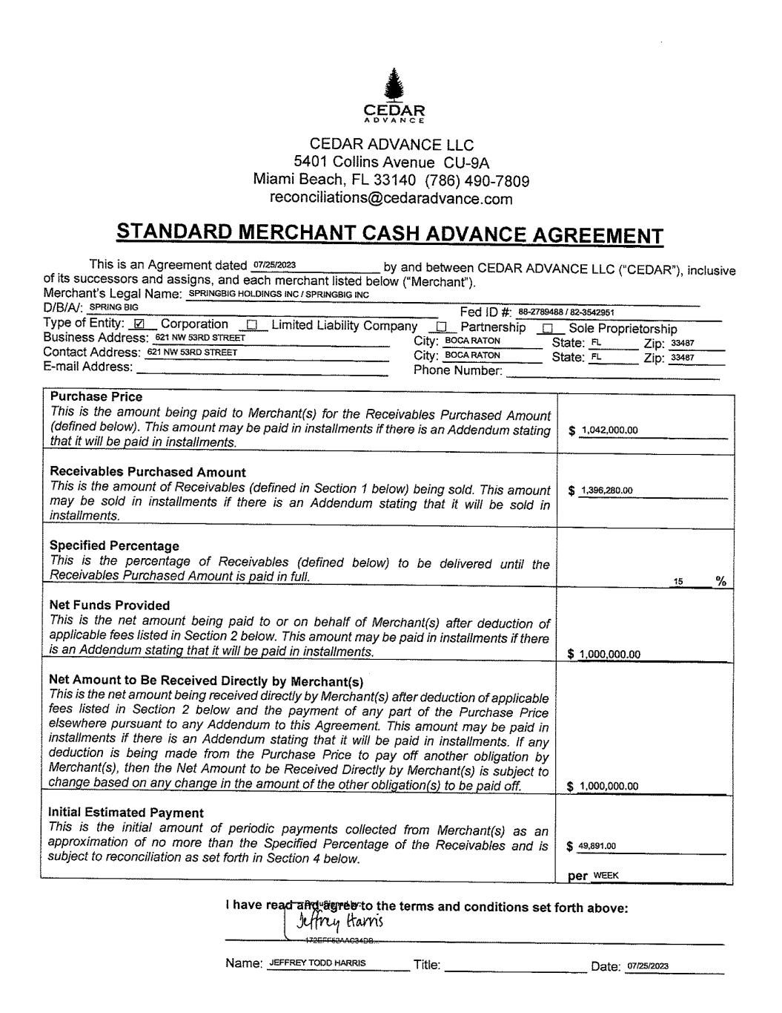
41

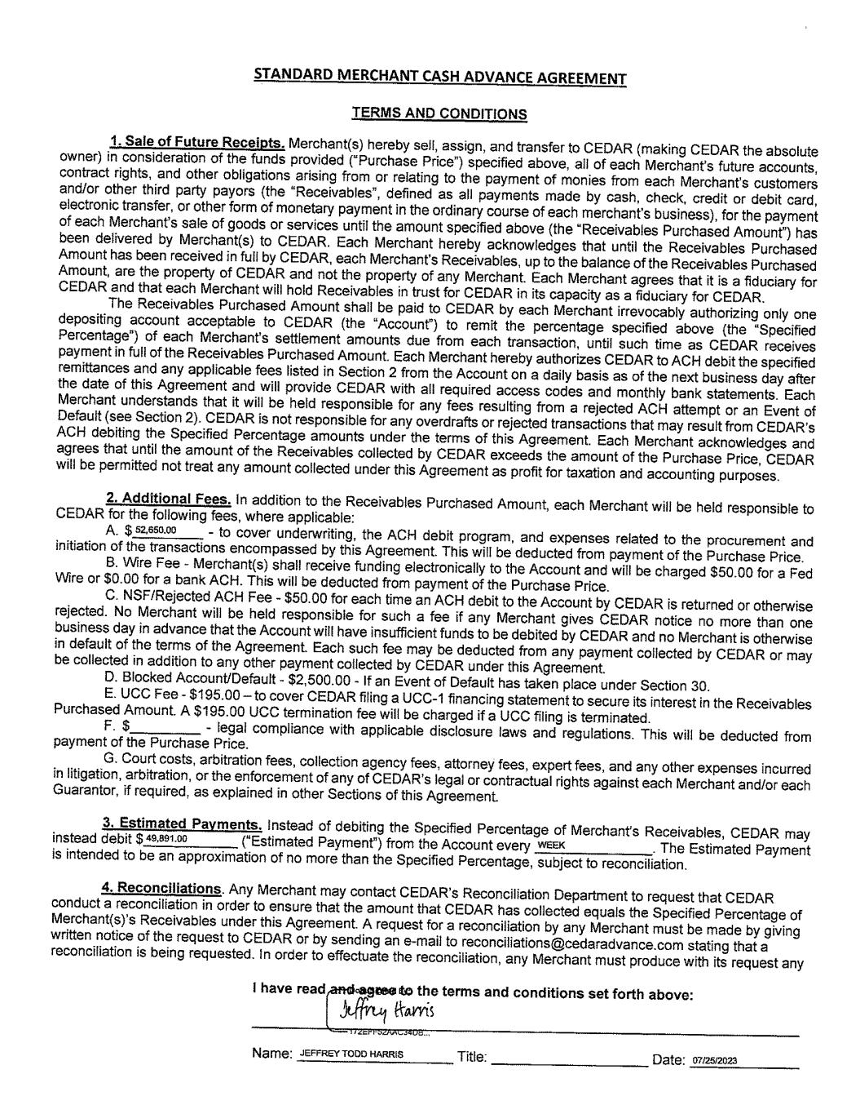

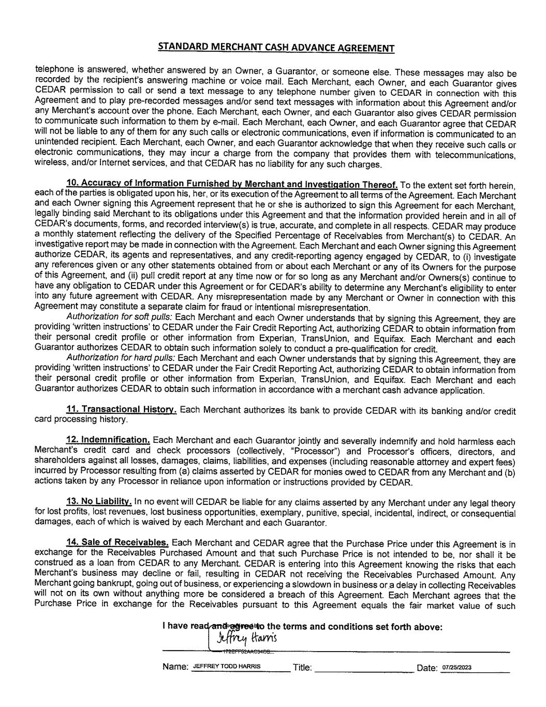

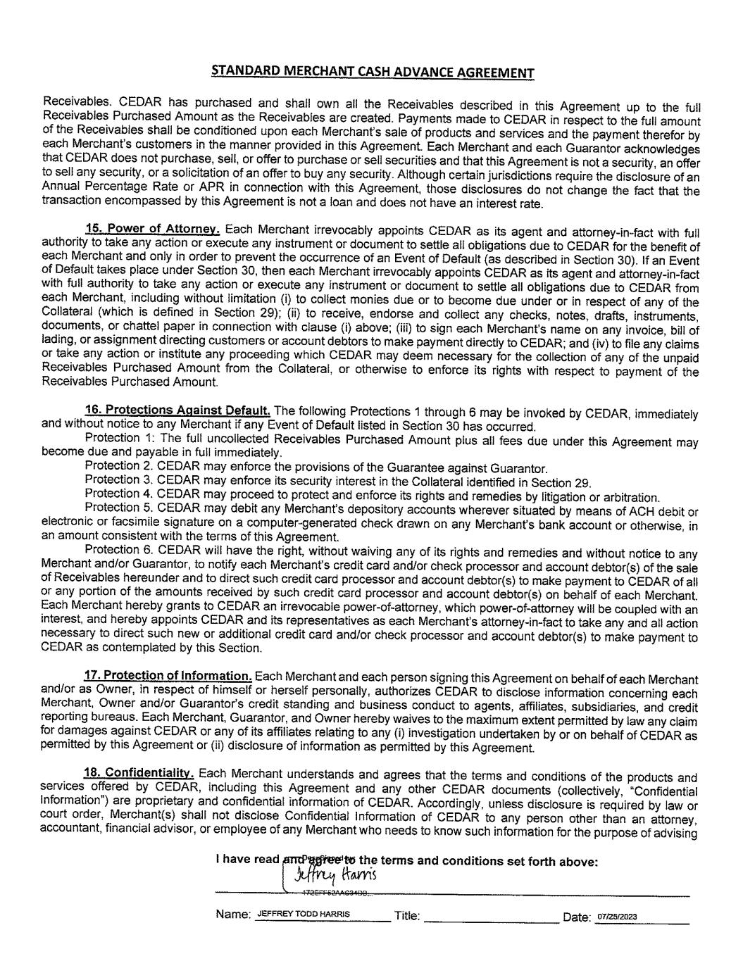

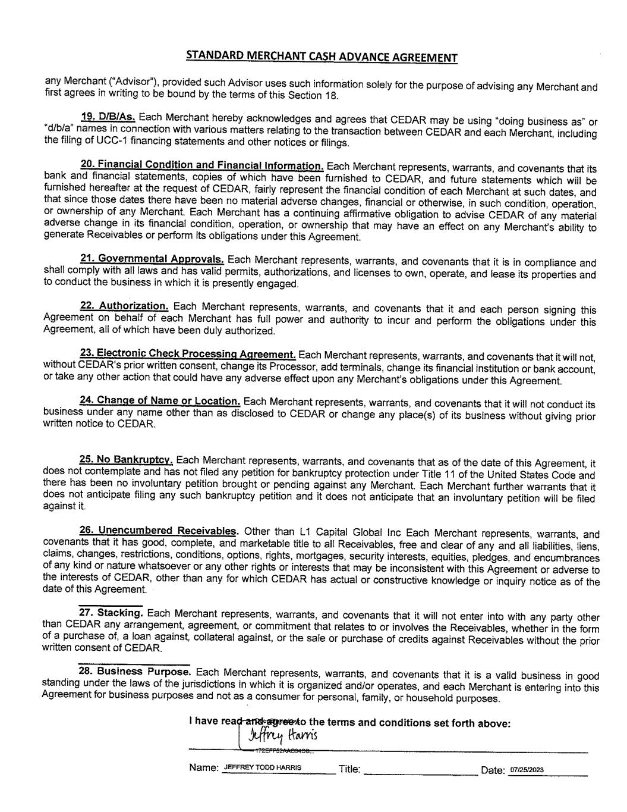

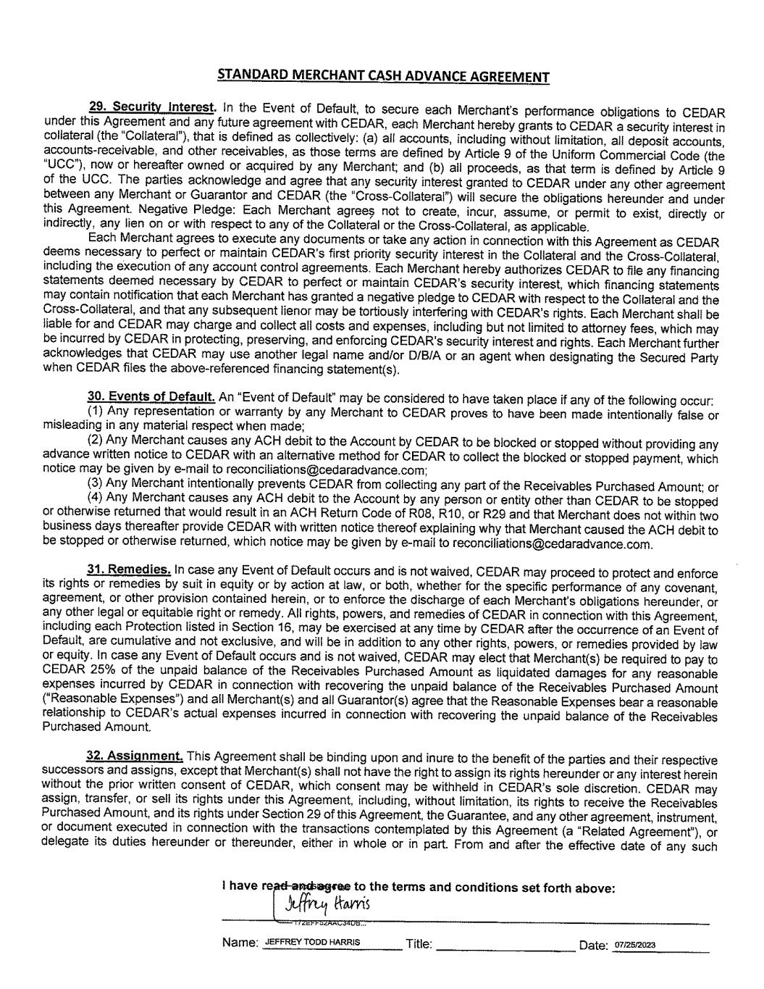

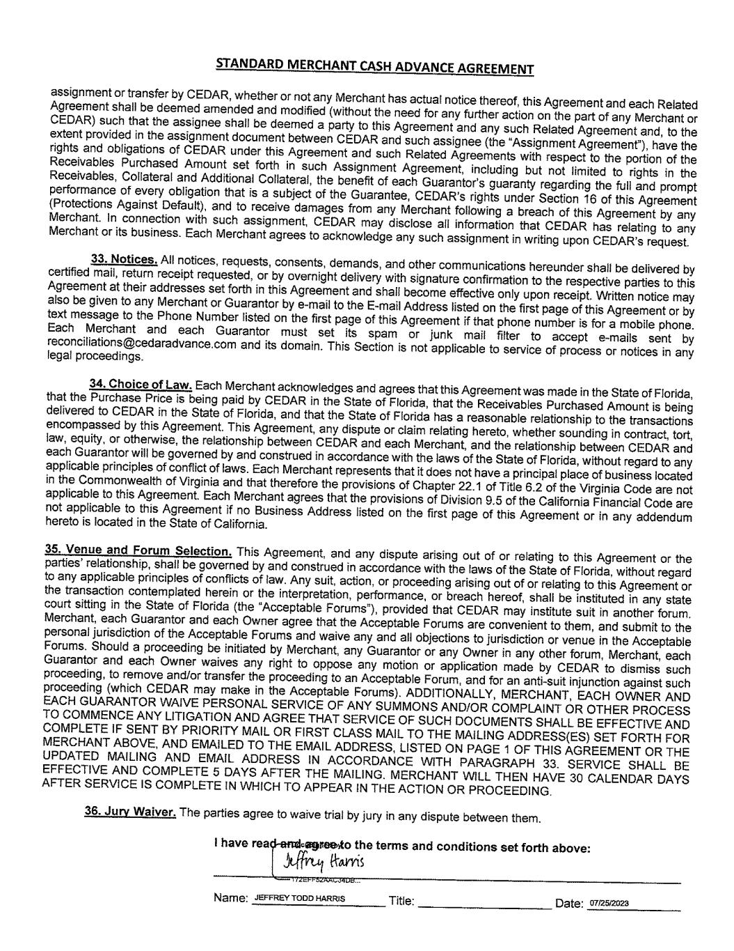

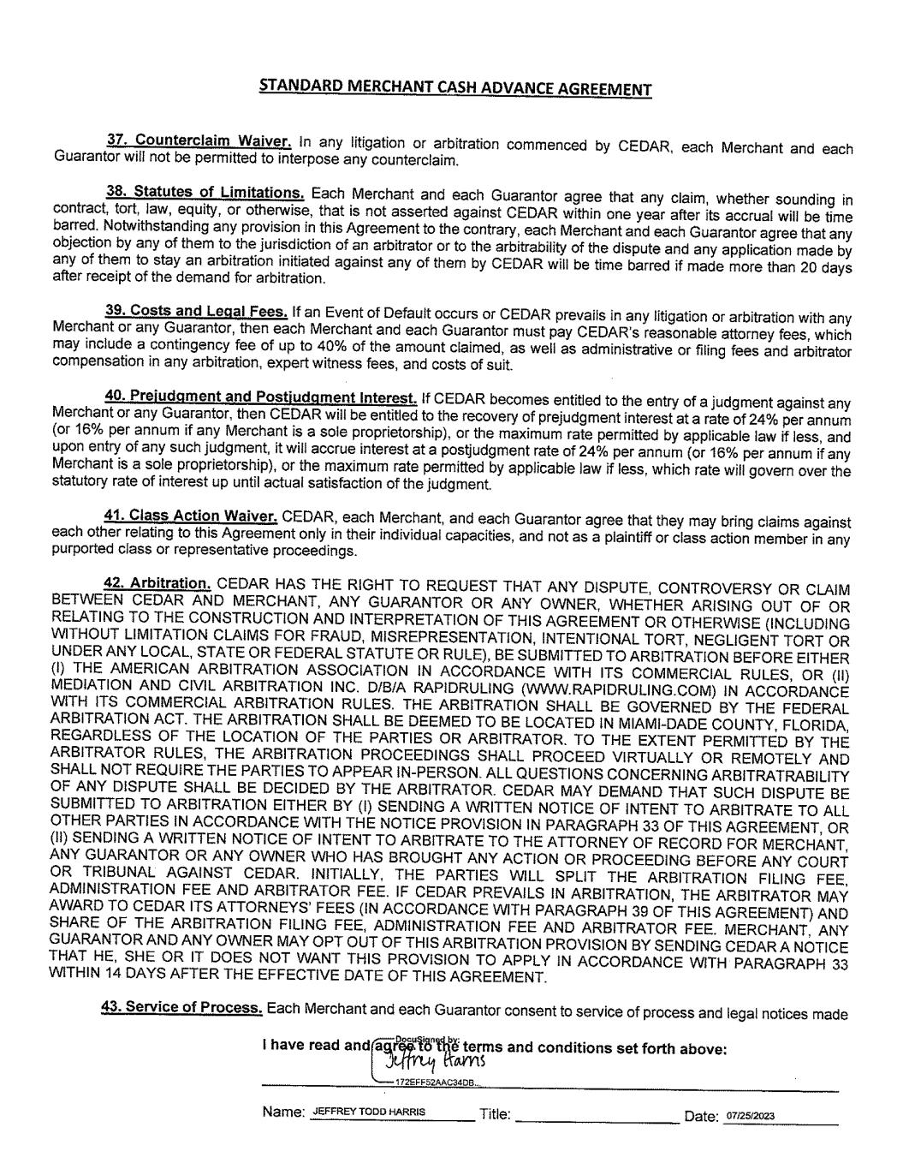

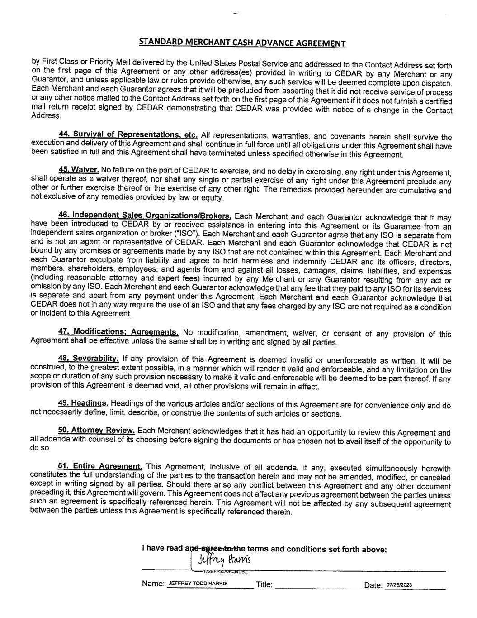

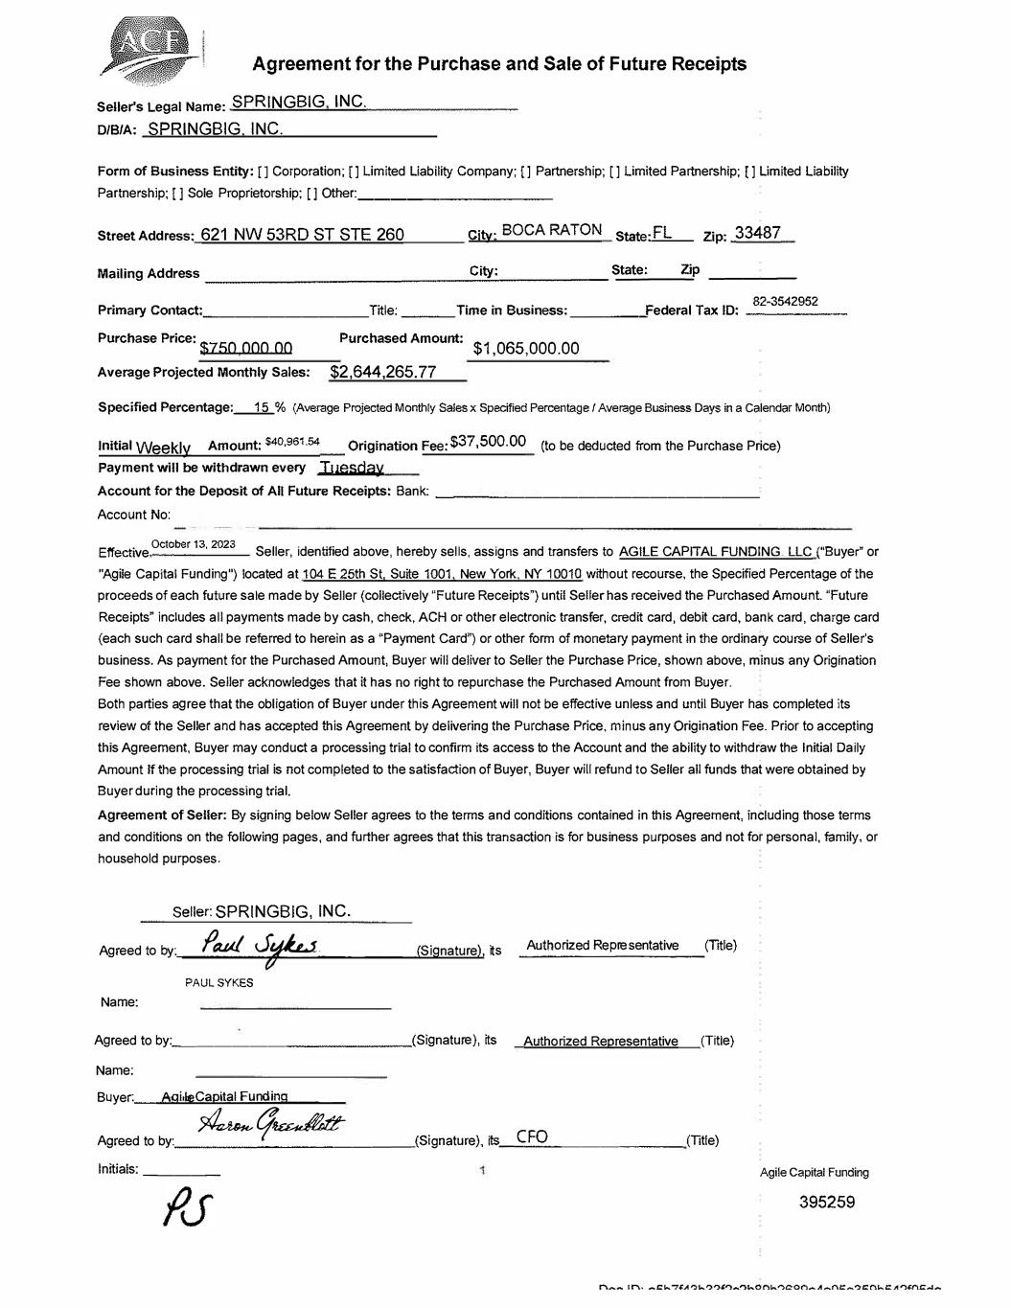
Agreement for the Purchase and Sale of Future Receipts Seller's Legal Name: SPRINGBIG INC. DIBIA: SPRINGBIG INC. Form of Business Entity: [] Corporation; [] Limited Liability Company; [] Partnership; [] Limited Partnership; [] Limited Liability Partnership; [] Sole Proprietorship; [] Other: ___________ _ Street Address: 621 NW 53RD ST STE 260 City· BOCA RATON State:.EL_ Zip: 33487 Mailing Address _______________ C::.;i::,tyc:.: ______ S:ct=at::ec.: _ _:Zi::,P ____ _ 82-3542952Primary Contact: __________ Title: ___ Time in Business: ____ _,Federal Tax ID: _____ _ Purchase Price: $?50,000.00 Average Projected Monthly Sales: Purchased Amount: $2,644,265.77 $1,065,000.00 Specified Percentage:----1§_ % (Average Projected Monthly Sales x Specified Percentage I Average Business Days in a Calendar Month} Initial Weekly Amount: $40,961 .54 Origination Fee:$37,500.00 (to be deducted from the Purchase Price) Payment will be withdrawn every Ti 1esday Account for the Deposit of All Future Receipts: Bank: _________________ _ Account No: Effective October 13' 2023 Seller, identified above, hereby sells, assigns and transfers to AGILE CAPITAL FUNDING LLC ("Buyer� or "Agile Capital Funding") located at 104 E 25th St, Suite 1001, New York NY 10010 without recourse, the Specified Percentage of the proceeds of each future sale made by Seller (collectively "Future Receipts") until Seller has received the Purchased Amount "Future Receipts" includes all payments made by cash, check, ACH or other electronic transfer, credit card, debit card, bank card, charge card (each such card shall be referred to herein as a "Payment Card") or other form of monetary payment in the ordinary course of Seller's business. As payment for the Purchased Amount, Buyer will deliver to Seller the Purchase Price, shown above, minus any Origination Fee shown above. Seller acknowledges that it has no right to repurchase the Purchased Amount from Buyer. Both parties agree that the obligation of Buyer under this Agreement will not be effective unless and until Buyer has completed its review of the Seller and has accepted this Agreement by delivering the Purchase Price, minus any Origination Fee. Prior to accepting this Agreement, Buyer may conduct a processing trial to confirm its access to the Account and the ability to withdraw the Initial Daily Amount If the processing trial is not completed to the satisfaction of Buyer, Buyer will refund to Seller all funds that were obtained by Buyer during the processing trial. Agreement of Seller: By signing below Seller agrees to the terms and conditions contained in this Agreement, including those terms and conditions on the following pages, and further agrees that this transaction is for business purposes and not for personal, family, or household purposes. Seller: SPRINGBIG, INC. Agreed to by:._ -�'-'-''av./-'-'--'Ji=-�.,,__=-'-------<Signature), tts PAUL SYKES Name: Agreed to by.: ______________ (Signature), tts Name: Buyer. .. _ _,A,,,q'"i"'lec,C,,,aeio,,it,sae.l ,:Fe_unc,da,i!!ng"----- _A_u_th_o_riz--'-ed_R ..c e :.. p _re_ s_e_nt_a_tiv_e _ (Title) Authorized Representative {Title) �CJ� Agreed to by· .._____ _:_ ______ (Signature), its,_-'C"-F-'O'--------- (Title) Initials: ____ _ Agile Capital Funding 395259

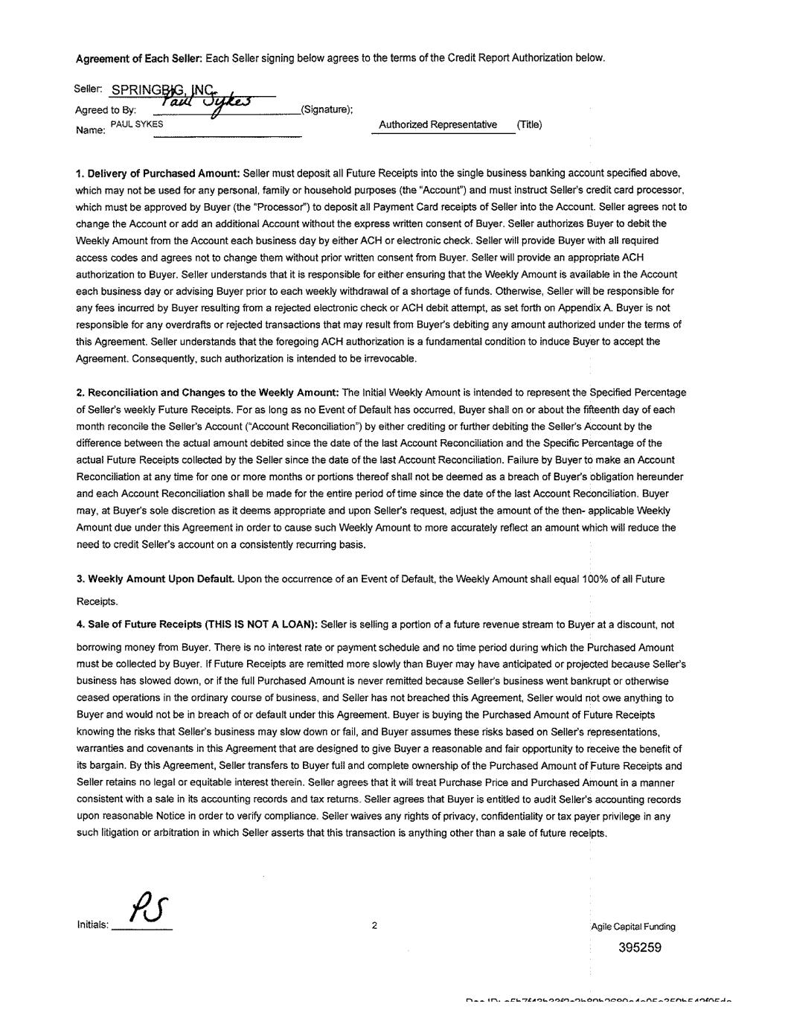

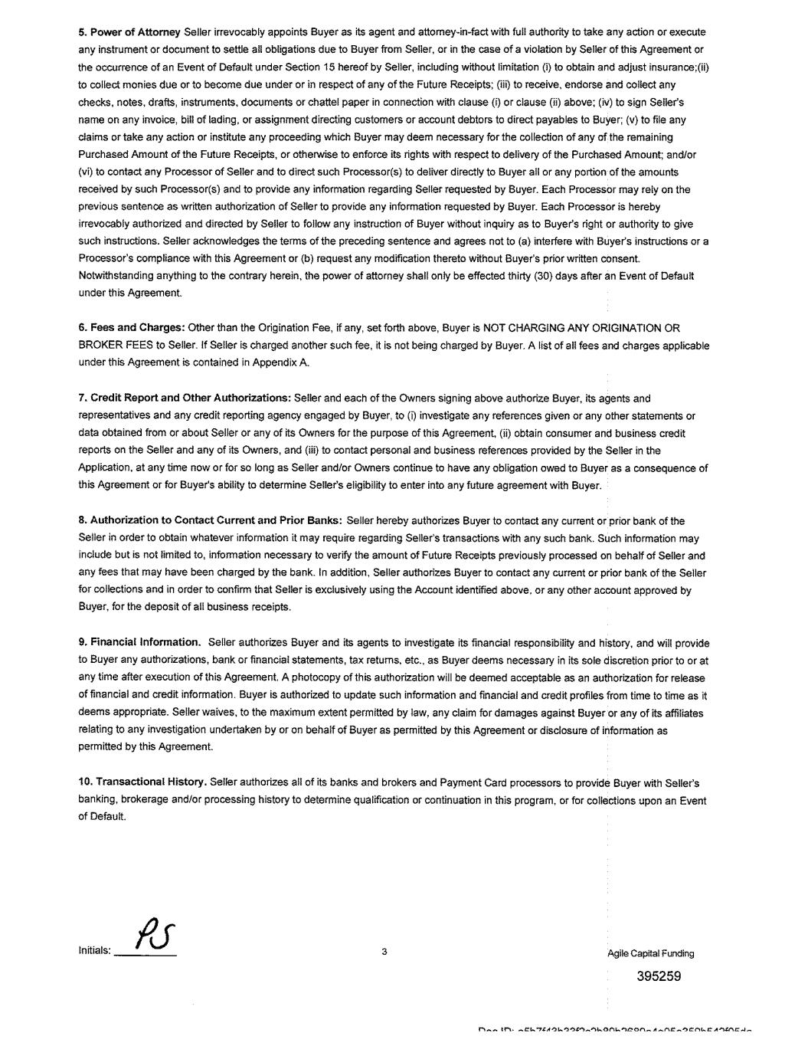

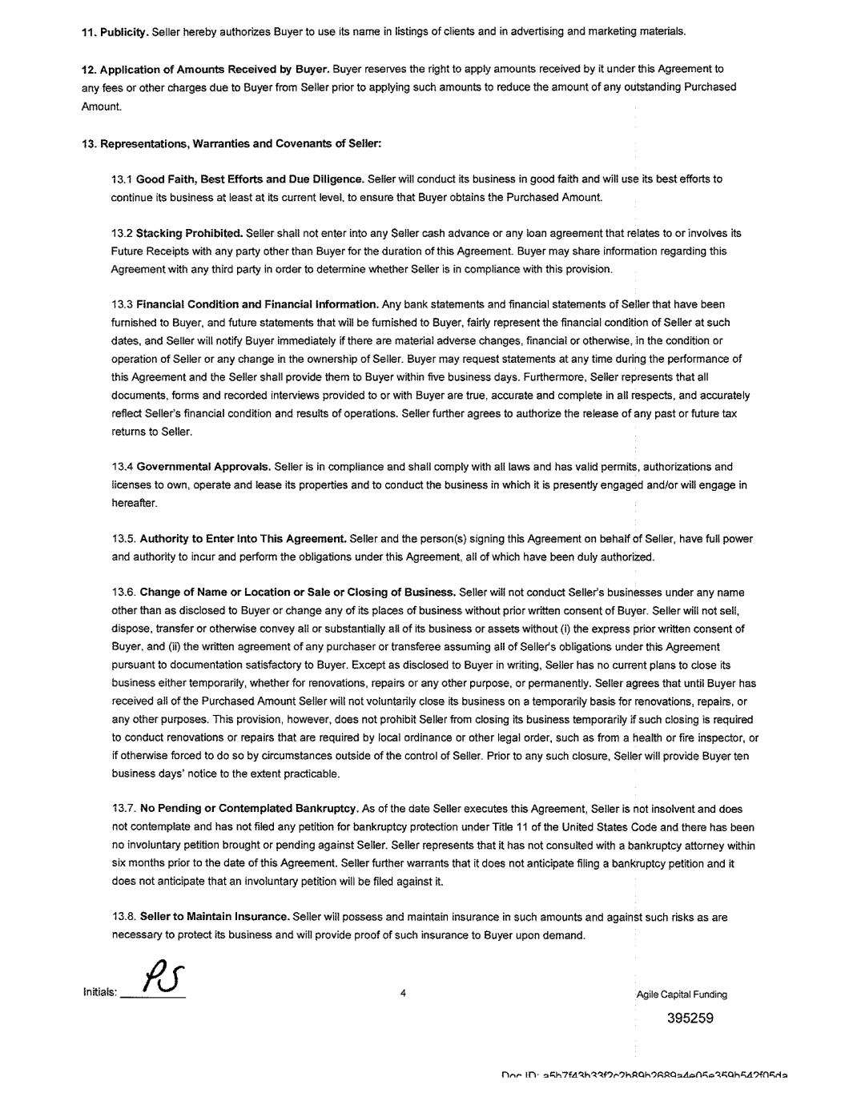

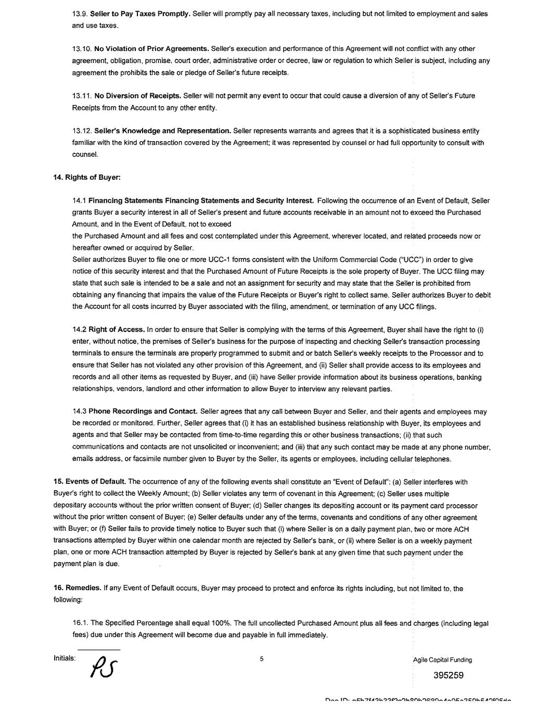

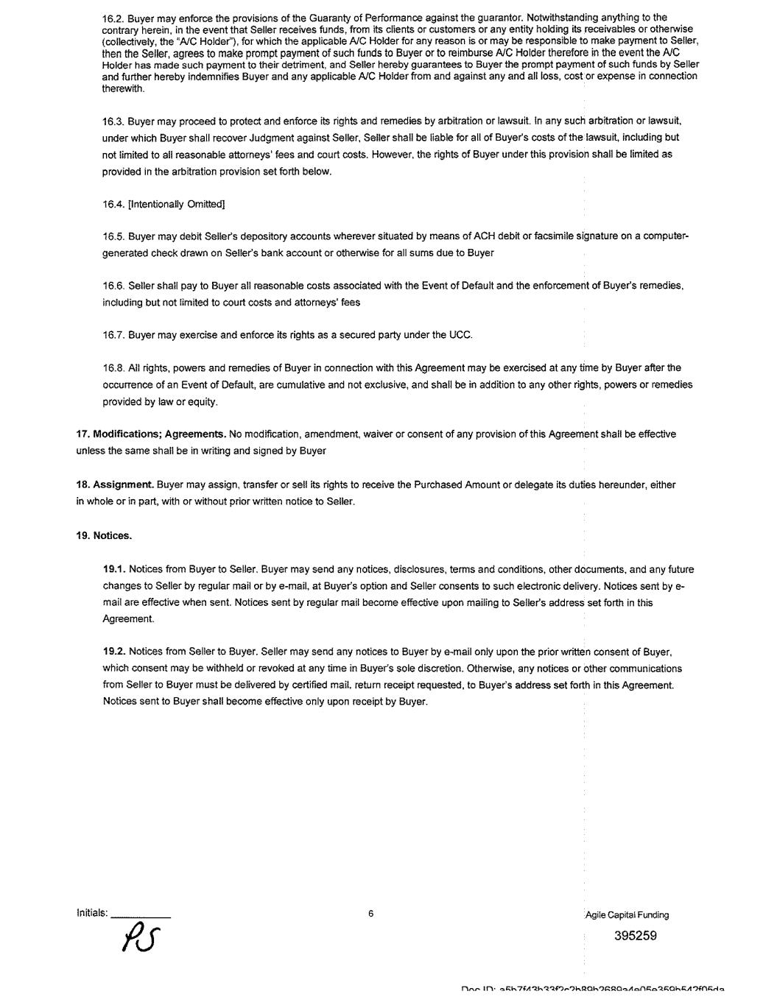

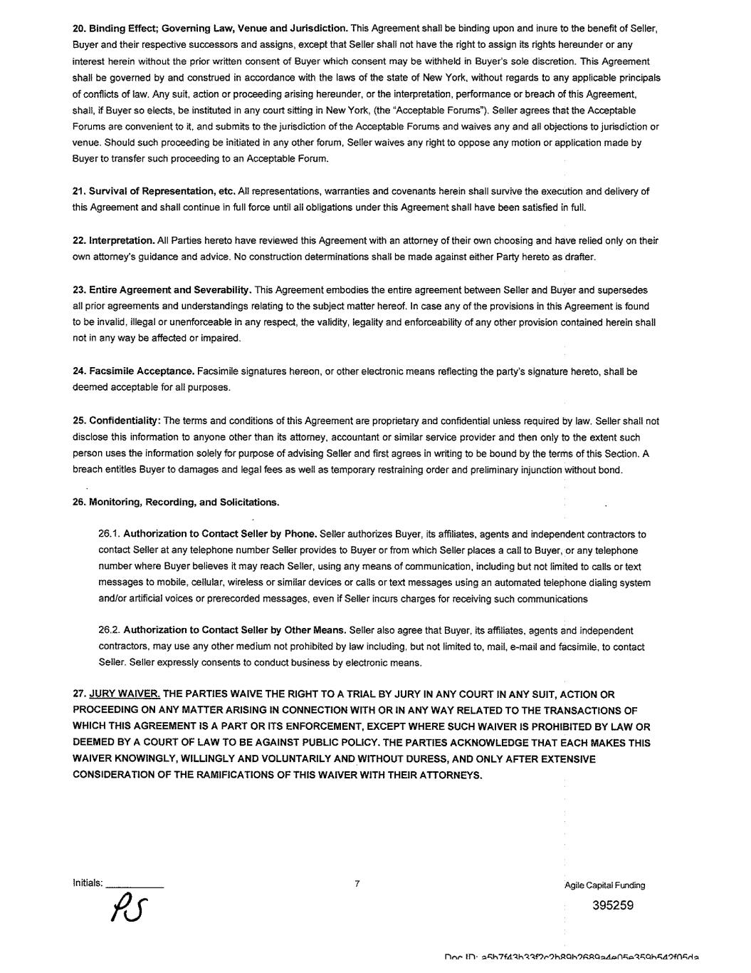

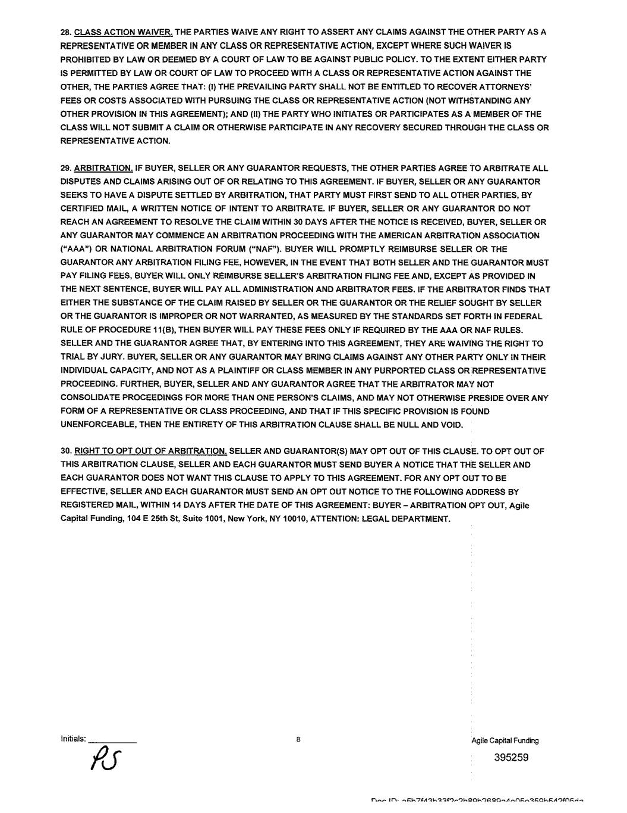

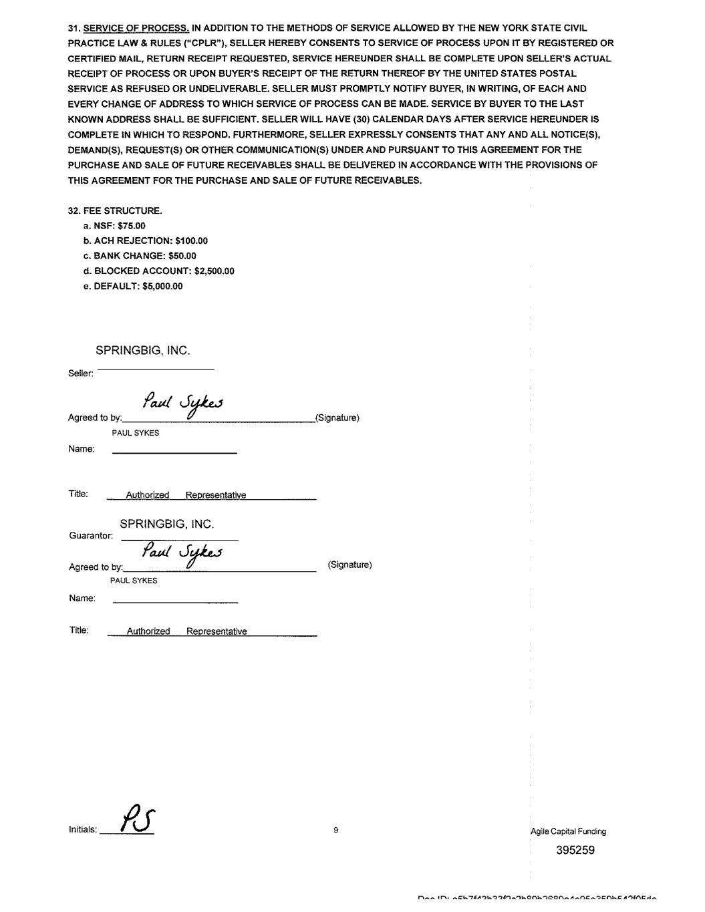

EXHIBIT 32.1

Certification by the Chief Executive Officer Pursuant to 18 U. S. C. Section 1350, as
Adopted Pursuant to Section 906 of the Sarbanes-Oxley Act of 2002

Pursuant to 18 U.S.C. Section 1350, I, Jeffrey Harris, hereby certify that, to the best of my knowledge, SpringBig Holdings, Inc’s Quarterly Report on Form 10-Q for the three months ended September 30, 2023 (the Report), as filed with the Securities and Exchange Commission on November 13, 2023, fully complies with the requirements of Section 13(a) or Section 15(d) of the Securities Exchange Act of 1934, as amended, and that the information contained in the Report fairly presents, in all material respects, the financial condition and results of operations of SpringBig Holdings, Inc.
/s/ Jeffrey Harris
Jeffrey Harris
Chief Executive Officer
November 13, 2023

EXHIBIT 32.2

Certification by the Chief Financial Officer Pursuant to 18 U. S. C. Section 1350, as
Adopted Pursuant to Section 906 of the Sarbanes-Oxley Act of 2002

Pursuant to 18 U.S.C. Section 1350, I, Paul Sykes, hereby certify that, to the best of my knowledge, SpringBig Holdings, Inc’s Quarterly Report on Form 10-Q for the three months ended September 30, 2023 (the Report), as filed with the Securities and Exchange Commission on November 13, 2023, fully complies with the requirements of Section 13(a) or Section 15(d) of the Securities Exchange Act of 1934, as amended, and that the information contained in the Report fairly presents, in all material respects, the financial condition and results of operations of SpringBig Holdings, Inc.
/s/ Paul Sykes
Paul Sykes
Chief Financial Officer
November 13, 2023

EXHIBIT 33.1

CERTIFICATION BY THE CHIEF EXECUTIVE OFFICER
PURSUANT TO SECTION 302 OF THE SARBANES-OXLEY ACT OF 2002

I, Jeffrey Harris, certify that:

1.I have reviewed this Quarterly Report on Form 10-Q for the three months ended September 30, 2023 of SpringBig Holdings, Inc.;

2.Based on my knowledge, this report does not contain any untrue statement of a material fact or omit to state a material fact necessary to make the statements made, in light of the circumstances under which such statements were made, not misleading with respect to the period covered by this report;

3.Based on my knowledge, the financial statements, and other financial information included in this report, fairly present in all material respects the financial condition, results of operations and cash flows of the registrant as of, and for, the periods presented in this report;

4.The registrant’s other certifying officer and I are responsible for establishing and maintaining disclosure controls and procedures (as defined in Exchange Act Rules 13a-15(e) and 15d-15(e)) and internal control over financial reporting (as defined by Exchange Act Rules 13a-15(f) and 15d-15(f)) for the registrant and have:

a.designed such disclosure controls and procedures, or caused such disclosure controls and procedures to be designed under our supervision, to ensure that material information relating to the registrant, including its consolidated subsidiaries, is made known to us by others within those entities, particularly during the period in which this report is being prepared;

b.designed such internal control over financial reporting, or caused such internal control over financial reporting to be designed under our supervision, to provide reasonable assurance regarding the reliability of financial reporting and the preparation of financial statements for external purposes in accordance with generally accepted accounting principles;

c.evaluated the effectiveness of the registrant’s disclosure controls and procedures and presented in this report our conclusions about the effectiveness of the disclosure controls and procedures, as of the end of the period covered by this report based on such evaluation; and

d.disclosed in this report any change in the registrant’s internal control over financial reporting that occurred during the registrant’s most recent fiscal quarter (the registrant’s fourth fiscal quarter in the case of an annual report) that has materially affected, or is reasonably likely to materially affect, the registrant’s internal control over financial reporting;

5.The registrant’s other certifying officer and I have disclosed, based on our most recent evaluation of internal control over financial reporting, to the registrant’s auditors and the audit committee of registrant’s board of directors (or persons performing the equivalent function):

a.all significant deficiencies and material weaknesses in the design or operation of internal controls over financial reporting, which are reasonably likely to adversely affect the registrant’s ability to record, process, summarize and report financial information; and

b.any fraud, whether or not material, that involves management or other employees who have a significant role in the registrant’s internal controls over financial reporting.

Date: November 13, 2023

/s/ Jeffrey Harris____________
Jeffrey Harris
Chief Executive Officer

EXHIBIT 33.2

CERTIFICATION BY THE CHIEF FINANCIAL OFFICER
PURSUANT TO SECTION 302 OF THE SARBANES-OXLEY ACT OF 2002

I, Paul Sykes, certify that:

1.I have reviewed this Quarterly Report on Form 10-Q for the three months ended September 30, 2023 of SpringBig Holdings, Inc.;

2.Based on my knowledge, this report does not contain any untrue statement of a material fact or omit to state a material fact necessary to make the statements made, in light of the circumstances under which such statements were made, not misleading with respect to the period covered by this report;

3.Based on my knowledge, the financial statements, and other financial information included in this report, fairly present in all material respects the financial condition, results of operations and cash flows of the registrant as of, and for, the periods presented in this report;

4.The registrant’s other certifying officer and I are responsible for establishing and maintaining disclosure controls and procedures (as defined in Exchange Act Rules 13a-15(e) and 15d-15(e)) and internal control over financial reporting (as defined by Exchange Act Rules 13a-15(f) and 15d-15(f)) for the registrant and have:

a.designed such disclosure controls and procedures, or caused such disclosure controls and procedures to be designed under our supervision, to ensure that material information relating to the registrant, including its consolidated subsidiaries, is made known to us by others within those entities, particularly during the period in which this report is being prepared;

b.designed such internal control over financial reporting, or caused such internal control over financial reporting to be designed under our supervision, to provide reasonable assurance regarding the reliability of financial reporting and the preparation of financial statements for external purposes in accordance with generally accepted accounting principles;

c.evaluated the effectiveness of the registrant’s disclosure controls and procedures and presented in this report our conclusions about the effectiveness of the disclosure controls and procedures, as of the end of the period covered by this report based on such evaluation; and

d.disclosed in this report any change in the registrant’s internal control over financial reporting that occurred during the registrant’s most recent fiscal quarter (the registrant’s fourth fiscal quarter in the case of an annual report) that has materially affected, or is reasonably likely to materially affect, the registrant’s internal control over financial reporting;

5.The registrant’s other certifying officer and I have disclosed, based on our most recent evaluation of internal control over financial reporting, to the registrant’s auditors and the audit committee of registrant’s board of directors (or persons performing the equivalent function):

a.all significant deficiencies and material weaknesses in the design or operation of internal controls over financial reporting, which are reasonably likely to adversely affect the registrant’s ability to record, process, summarize and report financial information; and

b.any fraud, whether or not material, that involves management or other employees who have a significant role in the registrant’s internal controls over financial reporting.

Date: November 13, 2023

/s/ Paul Sykes____________
Paul Sykes
Chief Financial Officer

